UNITED STATES

SECURITIES AND EXCHANGE COMMISSION

WASHINGTON, DC 20549
FORM 8-K

CURRENT REPORT

Pursuant to Section 13 or 15(d) of the

Securities Exchange Act of 1934

Date of report (Date of earliest event reported): October 28, 2026


T-MOBILE US, INC.

 | (Exact Name of Registrant as Specified in Charter)
Delaware | 1-33409 | 20-0836269
(State or other jurisdiction | (Commission File Number) | (I.R.S. Employer
of incorporation) |  | Identification No.)

12920 SE 38th Street

Bellevue, Washington

(Address of principal executive offices)

98006-1350

(Zip Code)

Registrant’s telephone number, including area code: (425) 378-4000

(Former Name or Former Address, if Changed Since Last Report):

Check the appropriate box below if the Form 8-K filing is intended to simultaneously satisfy the filing obligation of the registrant under any of the following provisions:

- Written communications pursuant to Rule 425 under the Securities Act (17 CFR 230.425)

- Soliciting material pursuant to Rule 14a-12 under the Exchange Act (17 CFR 240.14a-12)

- Pre-commencement communications pursuant to Rule 14d-2(b) under the Exchange Act (17 CFR 240.14d-2(b))

- Pre-commencement communications pursuant to Rule 13e-4(c) under the Exchange Act (17 CFR 240.13e-4(c))

Securities registered pursuant to Section 12(b) of the Act:

Title of each class | Trading Symbol(s) | Name of each exchange on which registered
Common Stock, par value $0.00001 per share | TMUS | The NASDAQ Stock Market LLC
3.550% Senior Notes due 2029 | TMUS29 | The NASDAQ Stock Market LLC
3.700% Senior Notes due 2032 | TMUS32 | The NASDAQ Stock Market LLC
3.150% Senior Notes due 2032 | TMUS32A | The NASDAQ Stock Market LLC
3.200% Senior Notes due 2032 | TMUS32B | The NASDAQ Stock Market LLC
3.625% Senior Notes due 2035 | TMUS35 | The NASDAQ Stock Market LLC
3.850% Senior Notes due 2036 | TMUS36 | The NASDAQ Stock Market LLC
3.500% Senior Notes due 2037 | TMUS37 | The NASDAQ Stock Market LLC
3.900% Senior Notes due 2038 | TMUS38 | The NASDAQ Stock Market LLC
3.800% Senior Notes due 2045 | TMUS45 | The NASDAQ Stock Market LLC
6.250% Senior Notes due 2069 | TMUSL | The NASDAQ Stock Market LLC
5.500% Senior Notes due March 2070 | TMUSZ | The NASDAQ Stock Market LLC
5.500% Senior Notes due June 2070 | TMUSI | The NASDAQ Stock Market LLC

Indicate by check mark whether the registrant is an emerging growth company as defined in Rule 405 of the Securities Act of 1933 (§ 230.405 of this chapter) or Rule 12b-2 of the Securities Exchange Act of 1934 (§ 240.12b-2 of this chapter).
Emerging growth company ☐

If an emerging growth company, indicate by check mark if the registrant has elected not to use the extended transition period for complying with any new or revised financial accounting standards provided pursuant to Section 13(a) of the Exchange Act. ☐

Item 2.02 — Results of Operations and Financial Condition

On October 28, 2026, T-Mobile US, Inc. (the “Company”) issued a press release announcing the financial and operating results of the Company for the quarter ended September 30, 2026. The text of the press release and accompanying Investor Factbook are furnished as Exhibits 99.1 and 99.2 and incorporated herein by reference.

The information in Item 2.02 to this Current Report on Form 8-K, including Exhibits 99.1 and 99.2, is being furnished and shall not be deemed “filed” for purposes of Section 18 of the Securities Exchange Act of 1934, as amended, or otherwise subject to the liabilities of that section, nor shall it be deemed incorporated by reference in any filing under the Securities Act of 1933, as amended, except as expressly set forth by specific reference in such filing.

Item 9.01 — Financial Statements and Exhibits

(d) Exhibits:

 | Exhibit |  | Description
99.1 |  |  | Press release, dated October 28, 2026, entitled "T-Mobile Delivers Strong Account and ARPA Growth, Translating into Industry-Leading
 |  |  | Service Revenue, Profitability and EPS Growth"
 | 99.2 |  | Investor Factbook of T-Mobile US, Inc. Third Quarter 2026 Results
 | 104 |  | Cover Page Interactive Data File (formatted as inline XBRL and contained in Exhibit 101)

SIGNATURES

Pursuant to the requirements of the Securities Exchange Act of 1934, the registrant has duly caused this report to be signed on its behalf by the undersigned hereunto duly authorized.

T-MOBILE US, INC.

October 28, 2026 /s/ Peter Osvaldik

Peter Osvaldik
Chief Financial Officer

EXHIBIT 99.1

T-Mobile Delivers Strong Account and ARPA Growth, Translating into Industry-Leading Service Revenue, Profitability and EPS Growth

Q3 Results Demonstrate the Un-carrier’s Widening Differentiation, with Best Network, Best Value and Best Experiences Deepening Customer Relationships and Driving Industry-Leading Financial Results

Continued Strong Account Growth and Deepening Customer Relationships Fueled by Widening Differentiation

- Postpaid Average Revenue Per Account (“ARPA”) of $155.73 grew 4% year-over-year

- Postpaid net account additions of 274 thousand, with total postpaid accounts of 35.0 million up 3% year-over-year

Translating Strong Account Growth into Durable and Profitable Financial Growth

- Service revenues of $19.4 billion grew 6% year-over-year, industry-leading growth⁽¹⁾

- Postpaid service revenues of $16.3 billion grew 9% year-over-year, industry-leading growth

- Net income of $3.5 billion grew 27% year-over-year, industry-leading growth

- Diluted earnings per share (“EPS”) of $3.22 grew 34% year-over-year, industry-leading growth

- Core Adjusted EBITDA⁽²⁾ of $9.6 billion grew 11% year-over-year, industry-leading growth

- Net cash provided by operating activities of $7.3 billion decreased 2% year-over-year

- Adjusted Free Cash Flow⁽²⁾ of $5.1 billion grew 5% year-over-year

Extending Overall Network Lead with Best Assets, Customer Centricity and Technology Leadership

- PCMag awarded T-Mobile Best Mobile Network (Major Carrier), Fastest Mobile Network, Best Mobile Network Coverage, Best Mobile Network Pricing (Major Carrier), and Highest Mobile Network Customer Satisfaction (Major Carrier)⁽³⁾
- T-Mobile recognized by Opensignal as the 5G Global Winner for 5G Coverage and for Time on 5G in large land-area markets⁽⁴⁾

- Ookla again ranked T-Mobile as the fastest 5G FWA provider in download & upload speeds⁽⁵⁾

- T-Mobile awarded Mobile Network Test Champion by P3 for the second consecutive quarter in their Q3 2026 US Benchmark, again sweeping all 13 award categories⁽⁶⁾

Bellevue, WA — October 28, 2026 — T-Mobile US, Inc. (NASDAQ: TMUS) reported third quarter 2026 results today, delivering strong postpaid net account and postpaid ARPA growth, both ahead of original expectations. The company’s robust account and ARPA growth contributed to industry-leading service revenue growth, including Postpaid service revenue growth, as well as industry-leading Net income growth and Core Adjusted EBITDA growth. The company also delivered strong Net cash provided by operating activities margin and Adjusted Free Cash Flow margin.

“Q3 marked another strong quarter and is further proof that our winning formula of the best network, best value, and best experiences drives durable and profitable growth,” said Srini Gopalan, CEO of T-Mobile. “More families and businesses are choosing T-Mobile, fueling our industry-leading financial growth. Our value proposition is clearly resonating for all customers, with our network as a significant driver of differentiation. We’re continuing to push the envelope on customer experience and innovation, with our best-in-class NPS underscoring our customer-first orientation. We have a tremendous growth runway ahead across core wireless, broadband, and smart adjacencies, and we’re just getting started.”

___________________________________________________________

- Industry-leading claims are based on consensus expectations if results are not yet reported.

- Core Adjusted EBITDA and Adjusted Free Cash Flow are non-GAAP financial measures. These non-GAAP financial measures should be considered in addition to, but not as a substitute for, the information provided in accordance with GAAP. Reconciliations for these non-GAAP financial measures to the most directly comparable GAAP financial measures are provided in the Reconciliation of Non-GAAP Financial Measures to GAAP Financial Measures tables. We are not able to forecast Net income on a forward-looking basis without unreasonable efforts due to the high variability and difficulty in predicting certain items that affect Net income, including, but not limited to, Special Items, Income tax expense and Interest expense. Core Adjusted EBITDA should not be used to predict Net income as the difference between this measure and Net income is variable.
- Based on PCMag's index of CoverageMap.com speed and 5G coverage test data (Jan. 1 to June 30, 2026), BestPhonePlans average unlimited plan pricing, and PCMag Readers' Choice survey results. PCMag The Best Mobile Networks in America 2026. Coverage award based on 5G coverage. Reprinted with permission. © 2026 Ziff Davis, LLC. All Rights Reserved.
- Opensignal Awards - 5G Global Mobile Network Experience Report, Sept 2026, Large land-area, based on independent analysis of mobile measurements recorded during the period Jan. 1 to June 29, 2026. © 2026 Opensignal Limited.
- Fastest according to Ookla Speedtest Intelligence data, 1H2026. All rights reserved.

- P3 US Mobile Benchmark Q3 2026.

1

Continued Strong Account Growth and Deepening Customer Relationships Fueled by Widening Differentiation

- Postpaid ARPA of $155.73 grew 4% year-over-year.

- Postpaid net account additions of 274 thousand, with total postpaid accounts of 35.0 million up 3% year-over-year. Postpaid account churn of 1.09%.

 |  |  | Quarter |  |  |  | Nine Months Ended
 |  |  | Quarter |  |  |  | September 30,
(in thousands, except churn and ARPA) | Q3 2026 |  | Q2 2026 |  | Q3 2025 |  | 2026 |  | 2025
Postpaid net account additions | 274 | 277 |  | 396 |  | 768 |  | 919
Total postpaid accounts, end of period ⁽¹⁾⁽²⁾⁽³⁾⁽⁴⁾⁽⁵⁾ | 34,974 | 34,700 |  | 33,979 |  | 34,974 |  | 33,979
Postpaid account churn | 1.09 % | 0.99 % |  | 0.97 % |  | 1.04 % |  | 0.94 %
Postpaid ARPA | $ 155.73 | $ 152.91 |  | $ 149.44 |  | $ 153.53 |  | $ 148.54

- In the second quarter of 2026, Metronet agreed to repurchase certain customer accounts, resulting in a base adjustment to decrease postpaid accounts by 16,000.

- In the first quarter of 2026, we recognized a base adjustment to decrease postpaid accounts by 18,000, primarily due to combining certain business accounts that have multiple billing account numbers.

- In the third quarter of 2025, we acquired 1,448,000 postpaid accounts through the UScellular acquisition, which includes the impact of certain base adjustments to align the policies of UScellular and T-Mobile.
- In the third quarter of 2025, we acquired 633,000 postpaid accounts from Metronet and other acquisitions.

- In the second quarter of 2025, we acquired 85,000 postpaid accounts from Lumos.

These base adjustments had no impact on postpaid net account additions.

Translating Strong Account Growth into Durable and Profitable Financial Growth

- Total service revenues increased 6% year-over-year to $19.4 billion, and Postpaid service revenues increased 9% year-over-year to $16.3 billion.

- Net income increased 27% year-over-year to $3.5 billion.

- Diluted EPS increased 34% year-over-year to $3.22 per share.

- Core Adjusted EBITDA increased 11% year-over-year to $9.6 billion.

- Net cash provided by operating activities decreased 2% year-over-year to $7.3 billion.

- Cash purchases of property and equipment, including capitalized interest, decreased 14% year-over-year to $2.3 billion.

- Adjusted Free Cash Flow increased 5% year-over-year to $5.1 billion.

- Stockholder Returns of $3.5 billion in Q3 2026, including common stock repurchases of $2.4 billion and cash dividends of $1.1 billion as part of the current stockholder return authorization of up to $18.2 billion through December 31, 2026, for cumulative stockholder returns⁽¹⁾ of $58.1 billion since program inception, split across stock repurchases of $46.7 billion and cash dividends of $11.5 billion.

 |  |  | Quarter |  |  |  |  | Nine Months Ended |  |  |  |  | Q3 2026 |  | Q3 2026 |  | YTD 2026
 |  |  | Quarter |  |  |  |  | September 30, |  |  |  |  | vs. |  | vs. |  | vs.
(in millions, except EPS) | Q3 2026 |  | Q2 2026 |  | Q3 2025 |  |  | 2026 |  |  | 2025 |  | Q2 2026 |  | Q3 2025 |  | YTD 2025
Total service revenues | $ 19,375 | $ 18,983 |  | $ 18,241 |  | $ |  | 57,189 | $ |  | 52,604 | 2.1 % |  | 6.2 % |  | 8.7 %
Postpaid service revenues | 16,269 | 15,853 |  | 14,882 |  |  |  | 47,751 |  |  | 42,554 | 2.6 % |  | 9.3 % |  | 12.2 %
Total revenues | 23,584 | 22,791 |  | 21,957 |  |  |  | 69,482 |  |  | 63,975 | 3.5 % |  | 7.4 % |  | 8.6 %
Net income | 3,455 | 3,239 |  | 2,714 |  |  |  | 9,198 |  |  | 8,889 | 6.7 % |  | 27.3 % |  | 3.5 %
Diluted EPS | 3.22 | 2.99 |  | 2.41 |  |  |  | 8.47 |  |  | 7.82 | 7.7 % |  | 33.6 % |  | 8.3 %
Adjusted EBITDA | 9,620 | 9,537 |  | 8,684 |  |  |  | 28,398 |  |  | 25,490 | 0.9 % |  | 10.8 % |  | 11.4 %
Core Adjusted EBITDA | 9,620 | 9,537 |  | 8,680 |  |  |  | 28,397 |  |  | 25,479 | 0.9 % |  | 10.8 % |  | 11.5 %
Net cash provided by operating activities | 7,341 | 7,500 |  | 7,457 |  |  |  | 22,063 |  |  | 21,296 | (2.1)% |  | (1.6)% |  | 3.6 %
Cash purchases of property and equipment, including | 2,270 | 2,703 |  | 2,639 |  |  |  | 7,596 |  |  | 7,486 | (16.0)% |  | (14.0)% |  | 1.5 %
capitalized interest | 2,270 |  |  |  |  |  |  | 7,596
Adjusted Free Cash Flow | 5,071 | 4,797 |  | 4,818 |  |  |  | 14,467 |  |  | 13,810 | 5.7 % |  | 5.3 % |  | 4.8 %

- Beginning in Q3 2022 through September 30, 2026.

2

Extending Overall Network Lead with Best Assets, Customer Centricity and Technology Leadership

- PCMag awarded T-Mobile Best Mobile Network (Major Carrier), Fastest Mobile Network, Best Mobile Network Coverage, Best Mobile Network Pricing (Major Carrier), and Highest Mobile Network Customer Satisfaction (Major Carrier).

- T-Mobile recognized by Opensignal as the 5G Global Winner for 5G Coverage and for Time on 5G in large land-area markets.

- Ookla again ranked T-Mobile as the fastest 5G FWA provider in download & upload speeds.

- T-Mobile awarded Mobile Network Test Champion by P3 for the second consecutive quarter in their Q3 2026 US Benchmark, again sweeping all 13 award categories.

See 5G device, coverage, and access details at T-Mobile.com. PCMag: Based on PCMag's index of CoverageMap.com speed and 5G coverage test data (Jan. 1 to June 30, 2026), BestPhonePlans average unlimited plan pricing, and

PCMag Readers' Choice survey results. PCMag The Best Mobile Networks in America 2026. Coverage award based on 5G coverage. Reprinted with permission. © 2026 Ziff Davis, LLC. All Rights Reserved. Opensignal: Opensignal

Awards - 5G Global Mobile Network Experience Report, Sept 2026, Large land-area, based on independent analysis of mobile measurements recorded during the period Jan. 1 to June 29, 2026. © 2026 Opensignal Limited. Ookla:
Fastest according to Ookla Speedtest Intelligence data, 1H2026. All rights reserved. P3: US Mobile Benchmark Q3 2026.

Raising Profitability and Cash Flow Guidance at the Midpoint

- Postpaid net account additions are expected to be approximately 1.0 million, at the midpoint of the previous guide of 950 thousand to 1.05 million.

- Effective tax rate is now expected to be between 24% and 25%, a decrease from prior guidance of between 25% and 26%.

- Core Adjusted EBITDA, which is Adjusted EBITDA less lease revenues, is expected to be between $37.35 billion and $37.45 billion, an increase at the midpoint from prior guidance of $37.1 billion to $37.5 billion.

- Net cash provided by operating activities, including net payments for UScellular merger-related costs, is now expected to be between $28.7 billion and $28.8 billion, an increase at the midpoint from prior guidance of $28.4 billion to $28.8 billion.

- Cash purchases of property and equipment, including capitalized interest, are expected to be approximately $10.0 billion.

- Adjusted Free Cash Flow, including net payments for UScellular merger-related costs, is now expected to be between $18.7 billion and $18.8 billion, an increase at the midpoint from prior guidance of $18.4 billion to $18.8 billion. Adjusted Free Cash Flow guidance does not assume any material net cash inflows from securitization.

(in millions, except Postpaid net account additions and Effective tax rate) | Previous |  |  | Current |  |  | Change
 |  |  |  |  |  |  | (Mid-point)
Postpaid net account additions (thousands) | 950 | 1,050 | ~1,000 |  |  |  | —
Net income (1) | N/A | N/A |  | N/A | N/A |  | N/A
Effective tax rate | 25% | 26% | 24% |  | 25% |  | (100) bps
Core Adjusted EBITDA (2) | $37,100 | $37,500 | $37,350 |  | $37,450 | $100
Net cash provided by operating activities | 28,400 | 28,800 | 28,700 |  | 28,800 | 150
Capital expenditures (3) | ~10,000 |  | ~10,000 |  |  |  | —
Adjusted Free Cash Flow | 18,400 | 18,800 | 18,700 |  | 18,800 | 150

- T-Mobile is not able to forecast Net income on a forward-looking basis without unreasonable efforts due to the high variability and difficulty in predicting certain items that affect GAAP Net income, including, but not limited to, Special Items, Income tax expense and Interest expense. Core Adjusted EBITDA should not be used to predict Net income as the difference between this measure and Net income is variable.
- Management uses Core Adjusted EBITDA as a measure to monitor the financial performance of company operations, excluding the impact of lease revenues from related device financing programs.

- Capital expenditures means cash purchases of property and equipment, including capitalized interest.

3

Financial Results

For more details on T-Mobile’s Q3 2026 financial results, including the Investor Factbook with detailed financial tables, please visit T-Mobile US, Inc.’s Investor Relations website at https://investor.t-mobile.com.

Earnings Call Information

Date/Time

- Wednesday, October 28, 2026, at 4:30 p.m. (EDT)

Pre-registration link for dial-in access and personalized PIN

Participants can pre-register for the conference call here in order to receive dial-in information and a personalized PIN. This option is recommended to avoid wait times when joining the call.

Access via Phone (audio only)

Please plan on accessing the call 10 minutes prior to the scheduled start time.

- Toll Free: 1-844-539-1320

- International: 1-412-652-1263

Access via Webcast

The earnings call will be broadcast live and can be replayed via the Investor Relations website at https://investor.t-mobile.com.

Submit Questions via X

Send a post to @TMobileIR or @SriniGopalan using $TMUS.

Contact Information

- Media Relations: mediarelations@t-mobile.com

- Investor Relations: investor.relations@t-mobile.com

T-Mobile Social Media

Investors and others should note that we announce material financial and operational information to our investors using our investor relations website (https://investor.t-mobile.com), newsroom website (https://t-mobile.com/news), press releases, SEC filings and public conference calls and webcasts. We also intend to use certain social media accounts as a means of disclosing information about us and our services and for complying with our disclosure obligations under Regulation FD (the @TMobileIR X account (https://x.com/TMobileIR), the @SriniGopalan X account (https://x.com/SriniGopalan) and our CEO’s LinkedIn account (https://www.linkedin.com/in/srini-gopalan/), both of which Mr. Gopalan also uses as a means for personal communications and observations, and the @TMobileCFO X account (https://x.com/tmobilecfo), and our CFO’s LinkedIn account (https://www.linkedin.com/in/peter-osvaldik-3887394), both of which Mr. Osvaldik also uses as a means for personal communications and observations). The information we post through these social media channels may be deemed material. Accordingly, investors should monitor these social media channels in addition to following our press releases, SEC filings and public conference calls and webcasts. The social media channels that we intend to use as a means of disclosing the information described above may be updated from time to time as listed on our investor relations website.

About T-Mobile US, Inc.

As the supercharged Un-carrier, T-Mobile US, Inc. (NASDAQ: TMUS) is powered by an award-winning nationwide 5G Advanced network that connects more people, in more places, than ever before. With T-Mobile’s unique value proposition of best network, best value and best experiences, the Un-carrier is redefining connectivity and fueling competition while continuing to drive the next wave of innovation in wireless, broadband and beyond. Headquartered in Bellevue, Wash., T-Mobile provides services through its subsidiaries and operates its flagship brands, T-Mobile, Metro by T-Mobile and Mint Mobile. For more information, visit https://www.t-mobile.com.

4

Forward-Looking Statements

This communication includes forward-looking statements within the meaning of the Private Securities Litigation Reform Act of 1995. All statements other than statements of historical fact, including information concerning T-Mobile US, Inc.’s future results of operations, are forward-looking statements. These forward-looking statements are generally identified by the words “anticipate,” “believe,” “estimate,” “expect,” “intend,” “may,” “could” or similar expressions.

Forward-looking statements are based on current expectations and assumptions, which are subject to risks and uncertainties and may cause actual results to differ materially from the forward-looking statements. Important factors that could affect future results and cause those results to differ materially from those expressed in the forward-looking statements include, among others, the following: competition, industry consolidation and changes in the market for wireless communications services and other forms of connectivity; cyberattacks, disruptions, data loss or other security breaches; our inability to adopt and deploy network technologies in a timely and effective manner; our inability to effectively execute our digital initiatives and drive customer and employee adoption of emerging technologies; our inability to retain or motivate key personnel, hire qualified personnel or maintain our corporate culture; system failures and business disruptions, allowing for unauthorized use of or interference with our network and other systems; the scarcity and cost of additional wireless spectrum, and regulations relating to spectrum use; the timing and effects of any pending and future acquisition, investment, joint venture, merger or divestiture involving us, including our inability to obtain any required regulatory approval necessary to consummate any such transactions or to achieve the expected benefits of such transactions; adverse economic, political or market conditions in the U.S. and international markets, including changes resulting from increases in oil prices, inflation or interest rates, tariffs and trade restrictions, supply chain disruptions, fluctuations in global currencies, immigration policies, and impacts of geopolitical instability, such as global conflict, wars and further escalations thereof; operational delays, higher procurement costs, such as memory chip cost impacts on smartphones, and operational costs, and increased regulatory and compliance complexities, for example, as a result of changes to trade policies, including higher tariffs, restrictions and other economic disincentives to trade; our inability to successfully deliver new products and services; any failure or inability of our third parties (including key suppliers) to provide products or services for the operation of our business; sociopolitical volatility and polarization and risks related to environmental, social and governance matters; our substantial level of indebtedness and our inability to service our debt obligations in accordance with their terms; changes in the credit market conditions, credit rating downgrades or an inability to access debt markets; our inability to maintain effective internal control over financial reporting; compliance with the current regulatory framework, including our national security obligations, and any changes in regulations or in the regulatory framework under which we operate; laws and regulations relating to the handling of privacy, data protection and artificial intelligence; unfavorable outcomes of and increased costs from existing or future regulatory or legal proceedings; difficulties in protecting our intellectual property rights or if we infringe on the intellectual property rights of others; our offering of regulated financial services products and exposure to a wide variety of state and federal regulations; new or amended tax laws or regulations or administrative interpretations and judicial decisions affecting the scope or application of tax laws or regulations; our wireless licenses, including those controlled through leasing agreements, are subject to renewal and may be revoked; our exclusive forum provision as provided in our Certificate of Incorporation; interests of Deutsche Telekom AG (“DT”), our controlling stockholder, which may differ from the interests of other stockholders; our current and future stockholder return programs may not be fully utilized, and our share repurchases and dividend payments pursuant thereto may fail to have the desired impact on stockholder value; future sales of our common stock by DT and our inability to attract additional equity financing outside the United States due to foreign ownership limitations by the Federal Communications Commission; and other risks as disclosed in our most recent annual report on Form 10-K, and subsequent Forms 10-Q and other filings with the Securities and Exchange Commission. Given these risks and uncertainties, readers are cautioned not to place undue reliance on such forward-looking statements. We undertake no obligation to revise or publicly release the results of any revision to these forward-looking statements, except as required by law.

5

T-Mobile US, Inc.

Reconciliation of Non-GAAP Financial Measures to GAAP Financial Measures

(Unaudited)

This Press Release includes non-GAAP financial measures, including Adjusted EBITDA, Core Adjusted EBITDA, Adjusted Free Cash Flow and Adjusted Free Cash Flow margin. The non-GAAP financial measures should be considered in addition to, but not as a substitute for, the information provided in accordance with GAAP. Reconciliations for the non-GAAP financial measures to the most directly comparable GAAP financial measures are provided below. T-Mobile is not able to forecast Net income on a forward-looking basis without unreasonable efforts due to the high variability and difficulty in predicting certain items that affect GAAP Net income, including, but not limited to, Special Items, Income tax expense and Interest expense. Adjusted EBITDA and Core Adjusted EBITDA should not be used to predict Net income as the difference between either of these measures and Net income is variable.

Adjusted EBITDA and Core Adjusted EBITDA are reconciled to Net income as follows:

 |  |  |  |  |  |  |  |  |  |  | Quarter |  |  |  |  |  |  |  |  |  |  |  | Nine Months Ended
 |  |  |  |  |  |  |  |  |  |  | Quarter |  |  |  |  |  |  |  |  |  |  |  | September 30,
(in millions) |  | Q1 2025 |  |  | Q2 2025 |  |  | Q3 2025 |  |  | Q4 2025 |  |  | Q1 2026 |  |  | Q2 2026 |  |  | Q3 2026 |  |  | 2025 |  |  | 2026
Net income | $ | 2,953 | $ |  | 3,222 | $ |  | 2,714 | $ |  | 2,103 | $ |  | 2,504 | $ |  | 3,239 | $ |  | 3,455 | $ |  | 8,889 | $ |  | 9,198
Adjustments:
Interest expense, net |  | 916 |  |  | 922 |  |  | 924 |  |  | 1,012 |  |  | 1,031 |  |  | 1,055 |  |  | 1,031 |  |  | 2,762 |  |  | 3,117
Other expense, net |  | 46 |  |  | 11 |  |  | 78 |  |  | 89 |  |  | 132 |  |  | 107 |  |  | 90 |  |  | 135 |  |  | 329
Income tax expense |  | 885 |  |  | 1,058 |  |  | 814 |  |  | 532 |  |  | 830 |  |  | 1,089 |  |  | 1,085 |  |  | 2,757 |  |  | 3,004
Operating income |  | 4,800 |  |  | 5,213 |  |  | 4,530 |  |  | 3,736 |  |  | 4,497 |  |  | 5,490 |  |  | 5,661 |  |  | 14,543 |  |  | 15,648
Depreciation and amortization |  | 3,198 |  |  | 3,146 |  |  | 3,408 |  |  | 3,756 |  |  | 3,817 |  |  | 3,434 |  |  | 3,452 |  |  | 9,752 |  |  | 10,703
Stock-based compensation ⁽¹⁾ |  | 168 |  |  | 178 |  |  | 217 |  |  | 209 |  |  | 203 |  |  | 212 |  |  | 195 |  |  | 563 |  |  | 610
UScellular merger-related costs |  | 14 |  |  | 33 |  |  | 73 |  |  | 143 |  |  | 406 |  |  | 182 |  |  | 129 |  |  | 120 |  |  | 717
Network restructuring initiative costs ⁽²⁾ |  | — |  |  | — |  |  | — |  |  | 93 |  |  | 76 |  |  | 52 |  |  | 38 |  |  | — |  |  | 166
Legal-related expenses (recoveries), net ⁽³⁾ |  | 6 |  |  | (4) |  |  | 8 |  |  | 6 |  |  | 54 |  |  | 16 |  |  | 14 |  |  | 10 |  |  | 84
Impairment expense |  | — |  |  | — |  |  | 278 |  |  | — |  |  | — |  |  | — |  |  | — |  |  | 278 |  |  | —
Other, net ⁽⁴⁾ |  | 73 |  |  | (19) |  |  | 170 |  |  | 504 |  |  | 188 |  |  | 151 |  |  | 131 |  |  | 224 |  |  | 470
Adjusted EBITDA |  | 8,259 |  |  | 8,547 |  |  | 8,684 |  |  | 8,447 |  |  | 9,241 |  |  | 9,537 |  |  | 9,620 |  |  | 25,490 |  |  | 28,398
Lease revenues |  | (1) |  |  | (6) |  |  | (4) |  |  | (2) |  |  | (1) |  |  | — |  |  | — |  |  | (11) |  |  | (1)
Core Adjusted EBITDA | $ | 8,258 |  | $ | 8,541 |  | $ | 8,680 |  | $ | 8,445 |  | $ | 9,240 |  | $ | 9,537 |  | $ | 9,620 |  | $ | 25,479 |  | $ | 28,397

- Stock-based compensation includes payroll tax impacts and may not agree to stock-based compensation expense in the Condensed Consolidated Financial Statements.

- In Q4 2025, we began implementing network restructuring initiatives as a result of recent technological advancements that enhanced our Customer-Driven Coverage insights. Network restructuring initiative costs consist of network decommissioning and contract termination costs related to the rationalization of our network and backhaul services and the elimination of duplicative costs.

- Legal-related expenses (recoveries), net consists of the settlement of certain litigation and compliance costs associated with the August 2021 cyberattack, net of insurance recoveries.

- Other, net, primarily consists of certain severance, restructuring and other expenses, gains and losses, not directly attributable to the UScellular acquisition, which are not reflective of T-Mobile’s ongoing core business activities and are, therefore, excluded from Adjusted EBITDA and Core Adjusted EBITDA. Other, net, for the three months ended March 31, 2026 and December 31, 2025, includes $141 million and $390 million, respectively, and $141 million for the nine months ended September 30, 2026, of severance and related costs associated with the 2025-2026 workforce transformation and reinvestment initiative. Additionally, Other, net, for the three months ended September 30, 2026 and June 30, 2026, includes $50 million and $108 million, respectively, and $158 million for the nine months ended September 30, 2026, of costs associated with retail initiatives to close certain dealer-and corporate-owned stores in connection with our ongoing digital initiatives to simplify routine transactions, as well as enhance customer experiences by transitioning in part to large-format experience stores.

Adjusted EBITDA represents earnings before Interest expense, net of Interest income, Income tax expense, Depreciation and amortization, stock-based compensation and certain expenses, gains and losses, which are not reflective of our ongoing operating performance (“Special Items”). Special Items include UScellular merger-related costs, network restructuring initiative costs (as discussed above), certain legal-related expenses and recoveries, Impairment expense, restructuring costs not directly attributable to the UScellular acquisition (including severance), and other non-core gains and losses. Core Adjusted EBITDA represents Adjusted EBITDA less device lease revenues. Core Adjusted EBITDA and Adjusted EBITDA are non-GAAP financial measures utilized by T-Mobile’s management, including our chief operating decision maker, to monitor the financial performance of our operations and allocate resources of the Company as a whole. T-Mobile historically used Adjusted EBITDA and T-Mobile currently uses Core Adjusted EBITDA internally as a measure to evaluate and compensate its personnel and management for their performance. T-Mobile uses Adjusted EBITDA and Core Adjusted EBITDA as benchmarks to evaluate its operating performance in comparison to competitors. Management believes analysts and investors use Core Adjusted EBITDA and Adjusted EBITDA as supplemental measures to evaluate overall operating performance and to facilitate comparisons with other wireless communications and broadband services companies because they are indicative of T-Mobile’s ongoing operating performance and trends by excluding the impact of Interest expense from financing, depreciation and amortization from capital investments, stock-based compensation and Special Items. Management believes analysts and investors use Core Adjusted EBITDA because it normalizes for the transition in the Company’s device financing strategy, by excluding the impact of device lease revenues from Adjusted EBITDA, to align with the exclusion of the related depreciation expense on leased devices from Adjusted EBITDA. Core Adjusted EBITDA and Adjusted EBITDA have limitations as analytical tools and should not be considered in isolation or as substitutes for Income from operations, Net income or any other measure of financial performance reported in accordance with U.S. Generally Accepted Accounting Principles (“GAAP”).

6

T-Mobile US, Inc.

Reconciliation of Non-GAAP Financial Measures to GAAP Financial Measures (continued)

(Unaudited)

Adjusted Free Cash Flow and Adjusted Free Cash Flow margin are calculated as follows:

 |  |  |  |  |  |  | Quarter |  |  |  |  |  |  |  | Nine Months Ended
 |  |  |  |  |  |  | Quarter |  |  |  |  |  |  |  | September 30,
(in millions, except percentages) | Q1 2025 |  | Q2 2025 |  | Q3 2025 |  | Q4 2025 |  | Q1 2026 |  | Q2 2026 |  | Q3 2026 |  | 2025 |  | 2026
Net cash provided by operating activities | $ 6,847 | $ 6,992 |  | $ 7,457 |  | $ 6,654 |  | $ 7,222 |  | $ 7,500 |  | $ 7,341 |  | $ 21,296 |  | $ 22,063

Cash purchases of property and equipment, including capitalized interest

Adjusted Free Cash Flow

Net cash provided by operating activities margin

(Net cash provided by operating activities divided by Service revenues)

Adjusted Free Cash Flow margin (Adjusted Free Cash Flow divided by Service revenues)

(2,451) |  | (2,396) |  | (2,639) |  | (2,469) |  | (2,623) |  | (2,703) |  | (2,270) |  | (7,486) |  | (7,596)
$ 4,396 |  | $ 4,596 |  | $ 4,818 |  | $ 4,185 |  | $ 4,599 |  | $ 4,797 |  | $ 5,071 |  | $ 13,810 |  | $ 14,467
40.5 % |  | 40.1 % |  | 40.9 % |  | 35.6 % |  | 38.4 % |  | 39.5 % |  | 37.9 % |  | 40.5 % |  | 38.6 %
26.0 % |  | 26.4 % |  | 26.4 % |  | 22.4 % |  | 24.4 % |  | 25.3 % |  | 26.2 % |  | 26.3 % |  | 25.3 %

Adjusted Free Cash Flow - Net cash provided by operating activities less cash payments for purchases of property and equipment, including capitalized interest. Adjusted Free Cash Flow is utilized by T-Mobile’s management, investors and analysts to evaluate cash available to pay debt, repurchase shares, pay dividends and provide further investment in the business.

Adjusted Free Cash Flow margin - Adjusted Free Cash Flow divided by Service revenues. Adjusted Free Cash Flow margin is utilized by T-Mobile’s management, investors, and analysts to evaluate the company’s ability to convert service revenue efficiently into cash available to pay debt, repurchase shares, pay dividends and provide further investment in the business.

7

T-Mobile US, Inc.

Operating Measures

(Unaudited)

The following table sets forth Postpaid ARPA:

 |  |  |  |  |  |  |  | Quarter |  |  |  |  |  |  |  |  |  | Nine Months Ended
 |  |  |  |  |  |  |  | Quarter |  |  |  |  |  |  |  |  |  | September 30,
 | Q1 2025 |  |  | Q2 2025 |  | Q3 2025 |  | Q4 2025 |  | Q1 2026 |  |  | Q2 2026 |  |  | Q3 2026 |  | 2025 |  |  | 2026
Postpaid ARPA | $ 146.22 | $ |  | 149.87 | $ 149.44 |  | $ 150.17 |  | $ 151.93 |  | $ |  | 152.91 | $ |  | 155.73 | $ 148.54 |  | $ |  | 153.53

Postpaid ARPA - Average monthly postpaid service revenue earned per account. Postpaid service revenues for the specified period divided by the average number of postpaid accounts during the period, further divided by the number of months in the period.

8

EXHIBIT 99.2


2

3 | Highlights
4 | Account Metrics
6 | Financial Metrics
12 | Capital Structure
13 | Guidance
14 | Contacts
15 | Financial and Operational Tables

3
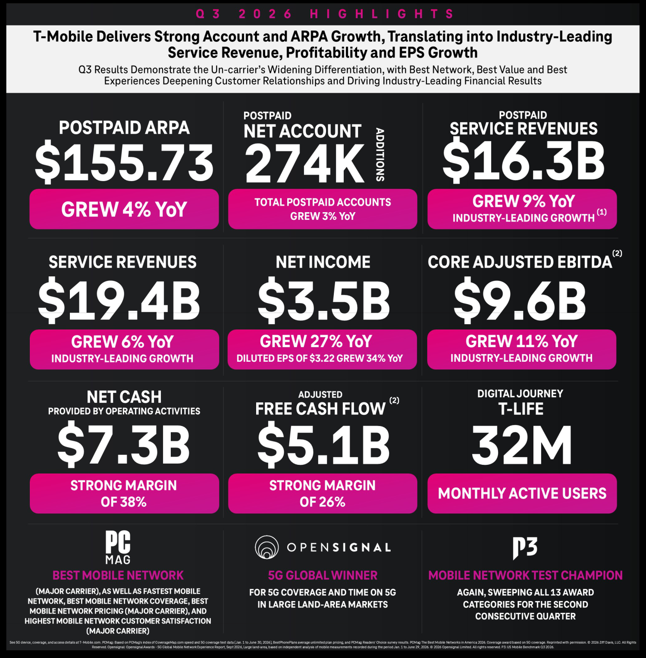

- Industry-leading claims are based on consensus expectations if results are not yet reported.

- Core Adjusted EBITDA, Adjusted Free Cash Flow and Adjusted Free Cash Flow margin are non-GAAP financial measures. These non-GAAP financial measures should be considered in addition to, but not as a substitute for, the information provided in accordance with GAAP. Reconciliations for these non-GAAP financial measures to the most directly comparable GAAP financial measures are provided in the Reconciliation of Non-GAAP Financial Measures to GAAP Financial Measures tables. We are not able to forecast Net income on a forward-looking basis without unreasonable efforts due to the high variability and difficulty in predicting certain items that affect Net income, including, but not limited to, Special Items, Income tax expense and Interest expense. Core Adjusted EBITDA should not be used to predict Net income as the difference between this measure and Net income is variable.

4


Postpaid Accounts

(in thousands)
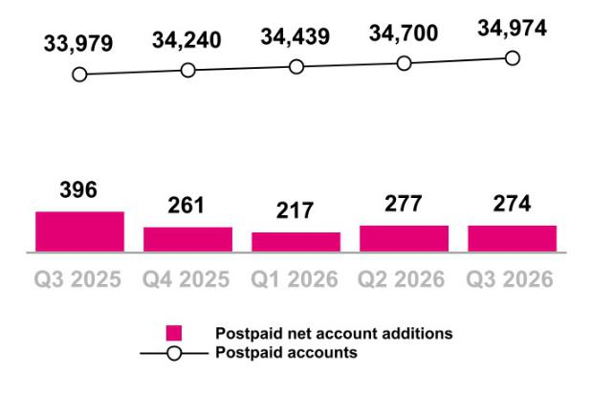

During Q3 2025, we acquired 1,448,000 postpaid accounts, net of certain base adjustments, through the UScellular acquisition.

During Q3 2025, we acquired 633,000 postpaid accounts from Metronet and other acquisitions.

During Q1 2026, we recognized a base adjustment to decrease postpaid accounts by 18,000, primarily due to combining certain business accounts that have multiple billing account numbers.

During Q2 2026, Metronet agreed to repurchase certain customer accounts, resulting in a base adjustment to decrease postpaid accounts by 16,000.

These base adjustments had no impact on postpaid net account additions.

Year-Over-Year

Continued growth in Postpaid accounts with a decrease in net additions primarily due to:

- Higher account deactivations driven by higher average broadband-only accounts which have higher churn, the temporary impact of our rate plan modernization, and the impact of a growing account base, including following the acquisitions of UScellular and Metronet during Q3 2025

Sequential

Continued growth in Postpaid accounts with a slight decrease in net additions primarily due to:

- Higher account deactivations driven by the temporary impact of our rate plan modernization, higher average broadband-only accounts which have higher churn, and seasonally higher switching activity

- Mostly offset by higher gross account additions, including seasonally higher switching activity

Year-Over-Year |  |  | Postpaid ARPA
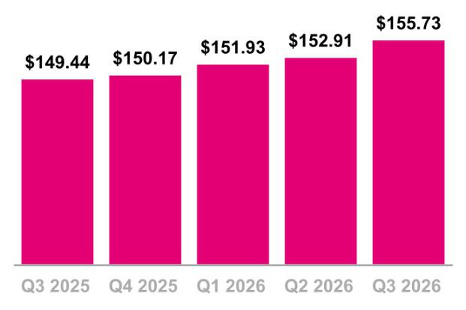

Postpaid ARPA increased 4% primarily due to:

- Higher fee revenue, including from the adoption of tax and fee exclusive plans, and the positive impact from our rate plan modernization

- An increase in customers per account, including from the continued adoption of 5G broadband and continued growth of T-Mobile for Business accounts, partially offset by fiber and UScellular accounts with fewer customers per account

- Partially offset by increased promotional activity, including the success of bundled offerings

Sequential

Postpaid ARPA increased 2% primarily due to:

- The positive impact from our rate plan modernization and higher fee revenue, including from the adoption of tax and fee exclusive plans

- Partially offset by increased promotional activity, including the success of bundled offerings

5

 |  |  | Postpaid Account Churn
Year-Over-Year |  |  | Postpaid Account Churn
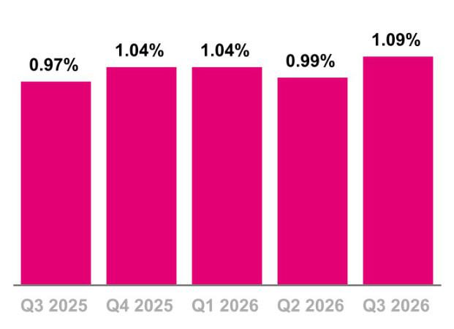

Postpaid account churn increased 12 basis points primarily due to:

- Higher average broadband-only accounts which have higher churn and the temporary impact of our rate plan modernization

Sequential

Postpaid account churn increased 10 basis points primarily due to:

- The temporary impact of our rate plan modernization, higher average broadband-only accounts which have higher churn, and seasonally higher switching activity

6

Service Revenues
($ in millions)
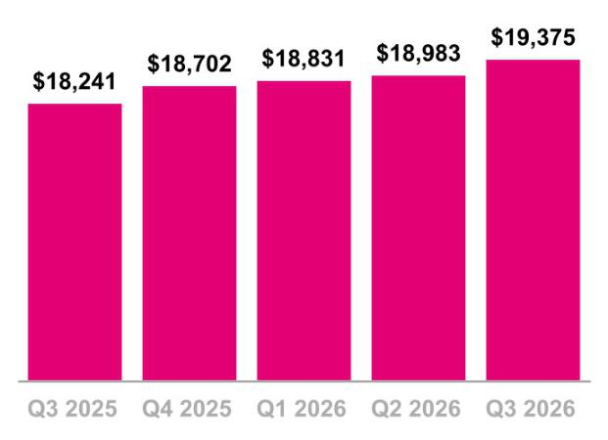

Year-Over-Year

Service revenues increased 6% primarily due to:

- An increase in Postpaid service revenues, including following the acquisitions of UScellular and Metronet during Q3 2025

- Partially offset by lower Prepaid service revenues

Sequential

Service revenues increased 2% primarily due to:

- An increase in Postpaid service revenues

Year-Over-Year

Postpaid service revenues increased 9% primarily due to:

- Higher average postpaid accounts, including following the acquisitions of UScellular and Metronet during Q3 2025

- Higher postpaid ARPA

Sequential

Postpaid service revenues increased 3% primarily due to:

- Higher postpaid ARPA

- Higher average postpaid accounts

Postpaid Service Revenues
($ in millions)

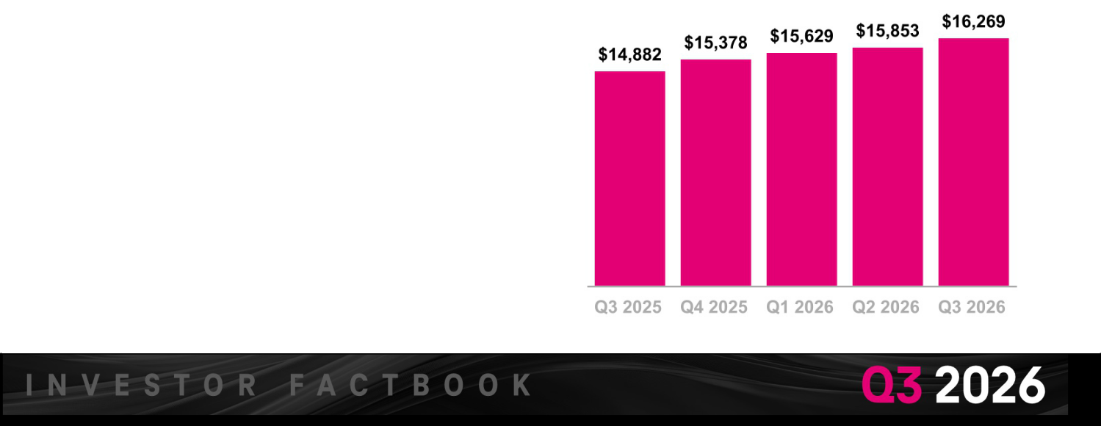

Equipment Revenues

($ in millions)
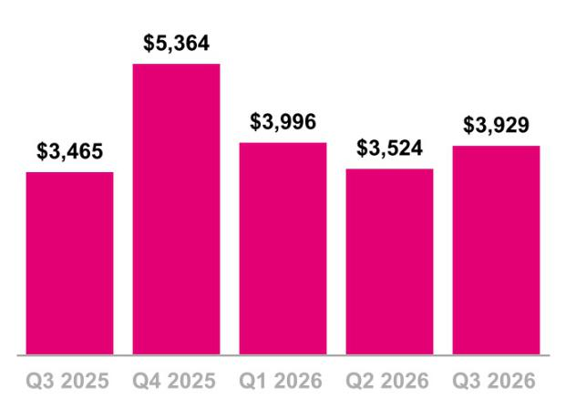

7

Year-Over-Year

Equipment revenues increased 13% primarily due to:

- Higher average revenue per device sold, net of promotions, primarily driven by an increase in the high-end phone mix and higher manufacturer pricing

- Higher liquidation revenue, primarily due to a higher number of liquidated devices and an increase in the high-end phone mix

- Partially offset by a decrease in the total number of devices sold, primarily driven by lower prepaid devices

Sequential

Equipment revenues increased 11% primarily due to:

- Higher average revenue per device sold, net of promotions, primarily driven by higher manufacturer pricing and an increase in the high-end phone mix

- A higher number of devices sold, including seasonal trends

Year-Over-Year

Cost of equipment sales, exclusive of Depreciation and

Amortization (D&A), increased 12% primarily due to:

- Higher average cost per device sold, primarily driven by higher manufacturer pricing and an increase in the high-end phone mix

- Higher liquidation costs, primarily due to a higher number of liquidated devices and an increase in the high-end phone mix
- Partially offset by a decrease in the total number of devices sold, primarily driven by lower prepaid devices

Sequential

Cost of equipment sales, exclusive of D&A, increased 8% primarily due to:

- Higher average cost per device sold, primarily driven by higher manufacturer pricing and an increase in the high-end phone mix

- A higher number of devices sold, including seasonal trends

Cost of Equipment Sales, exclusive of D&A

($ in millions, % of Equipment sales*)
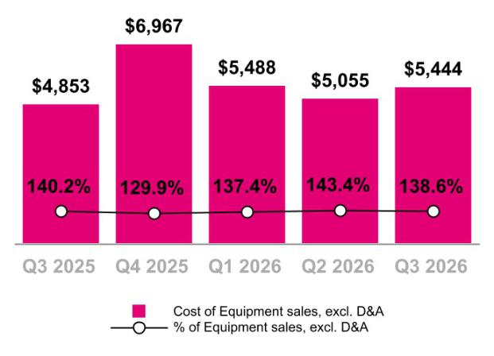

*Equipment sales is defined as Equipment revenues less Lease revenues.



Cost of Services, exclusive of D&A

($ in millions, % of Service revenues)
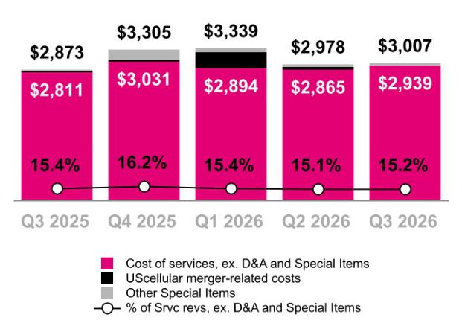

8

Year-Over-Year

Cost of services, exclusive of D&A, increased 5% primarily due to:

- Higher wholesale network access costs and amortization of customer installation fees paid to Metronet and Lumos

- Higher repair and maintenance expenses

Sequential

Cost of services, exclusive of D&A, increased slightly.

Year-Over-Year

SG&A expense was relatively flat primarily due to:

- Lower business tax refunds and credits

- Higher bad debt expense

- Offset by lower personnel-related costs, including payroll and benefits, and lower external labor and professional services expenses

Sequential

SG&A expense increased 3% primarily due to:

- Lower vendor credits related to software services

Selling, General and Administrative (SG&A) Expense
($ in millions, % of Service revenues)

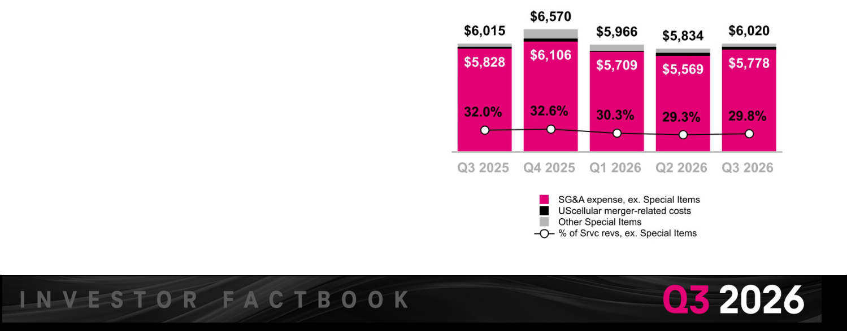

Net Income

($ in millions, % of Service revenues)
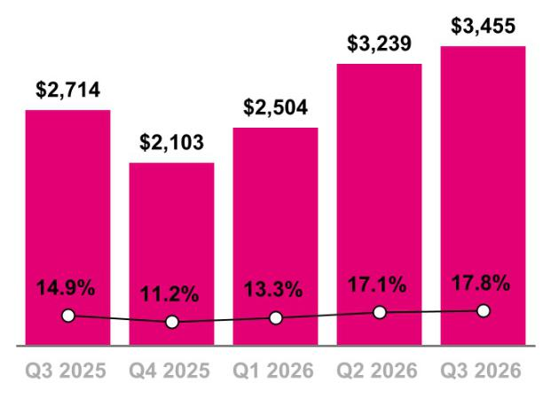

Diluted Earnings Per Share

(Diluted EPS)
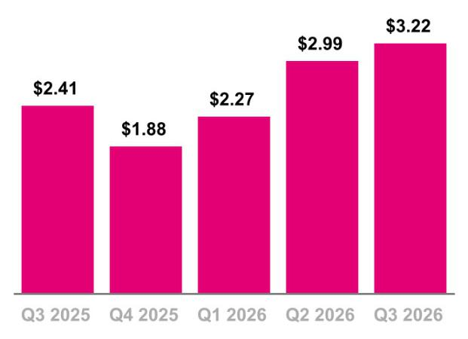

9

Year-Over-Year

Net income was $3.5 billion and Diluted earnings per share was $3.22 in Q3 2026, compared to $ 2.7 billion and $2.41 in Q3 2025, primarily due to the factors described above and included the following:

- UScellular merger-related costs, net of tax, of $98 million, or $0.09 per share, in Q3 2026 and $55 million, or $0.05 per share, in Q3 2025

- Impairment expense related to certain capitalized software development costs, net of tax, in Q3 2025 of $208 million, or $0.18 per share

Sequential

Net income was $3.5 billion and Diluted earnings per share was $3.22 in Q3 2026, compared to $ 3.2 billion and $2.99 in Q2 2026, primarily due to the factors described above and included the following:

- UScellular merger-related costs, net of tax, of $98 million, or $0.09 per share, in Q3 2026 and $146 million, or $0.14 per share, including accelerated depreciation, in Q2 2026

Core Adjusted EBITDA*

($ in millions, % of Service revenues)
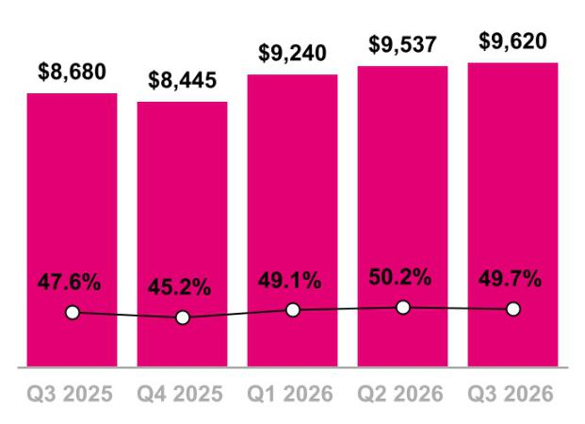

*Excludes Special Items (see detail on page 22)

10

Year-Over-Year

Core Adjusted EBITDA increased 11% primarily due to:

- Higher Total service revenues

- Higher Equipment revenues, excluding Lease revenues

- Partially offset by higher Cost of equipment sales, excluding Special Items, and higher Cost of services, excluding Special Items

Sequential

Core Adjusted EBITDA increased slightly, primarily due to:

- Higher Equipment revenues, excluding Lease revenues

- Higher Total service revenues

- Mostly offset by higher Cost of equipment sales, excluding Special Items, and higher SG&A expenses, excluding Special Items

Year-Over-Year

Net cash provided by operating activities decreased 2% primarily due to:

- Higher net cash outflows from changes in working capital

- Partially offset by higher Net income, adjusted for non-cash income and expenses

Sequential

Net cash provided by operating activities decreased 2% primarily due to:

- Higher net cash outflows from changes in working capital

The impact of Net payments for merger-related costs on Net cash provided by operating activities was $ 198 million in Q3 2026 compared to $181 million in Q2 2026 and $96 million in Q3 2025.

Net Cash Provided by Operating Activities
($ in millions)
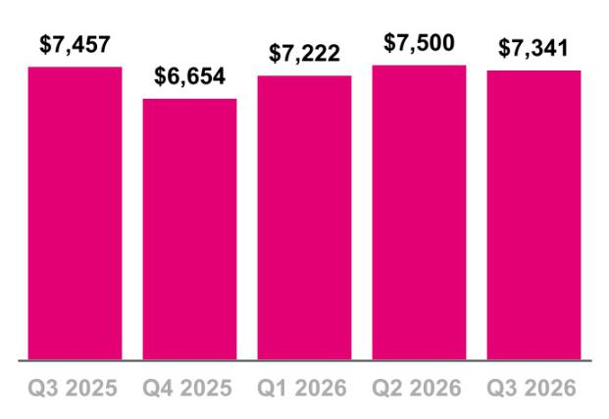

Cash Purchases of Property and Equipment, incl. Capitalized Interest

($ in millions, % of Service revenues)
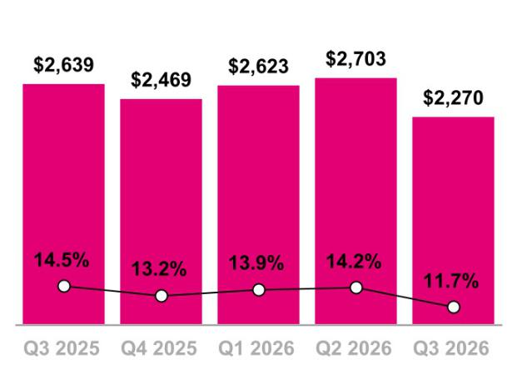

11

Year-Over-Year

Cash purchases of property and equipment, including capitalized interest, decreased 14% primarily due to:

- Planned timing of capital purchases

Sequential

Cash purchases of property and equipment, including capitalized interest, decreased 16% primarily due to:

- Planned timing of capital purchases

Year-Over-Year

Adjusted Free Cash Flow increased 5% primarily due to:

- Lower Cash purchases of property and equipment

- Partially offset by lower Net cash provided by operating activities

Sequential

Adjusted Free Cash Flow increased 6% primarily due to:

- Lower Cash purchases of property and equipment

- Partially offset by lower Net cash provided by operating activities

The impact of Net payments for merger-related costs on Adjusted Free Cash Flow was $198 million in Q3 2026 compared to $181 million in Q2 2026 and $96 million in Q3 2025.

Adjusted Free Cash Flow
($ in millions)
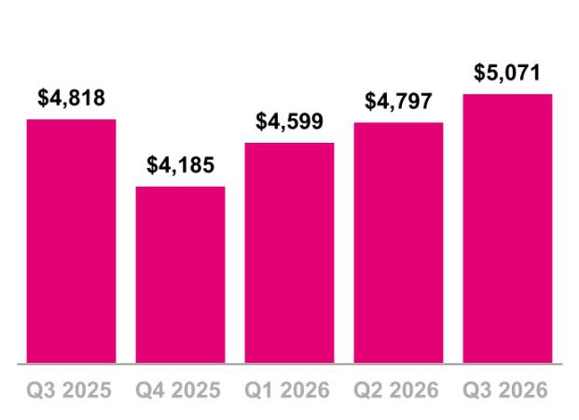

12

Total Debt (Excluding Tower Obligations),

Net Debt (Excluding Tower Obligations), and
Net Debt to LTM Net Income and Core Adj. EBITDA Ratios
($ in billions)
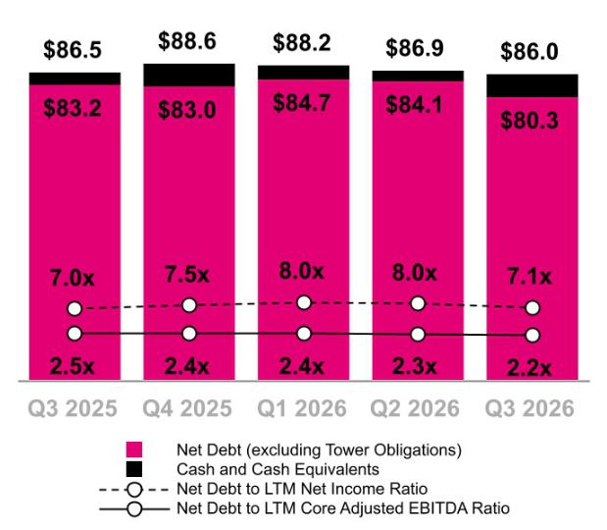

Stockholder Returns

($ in millions)
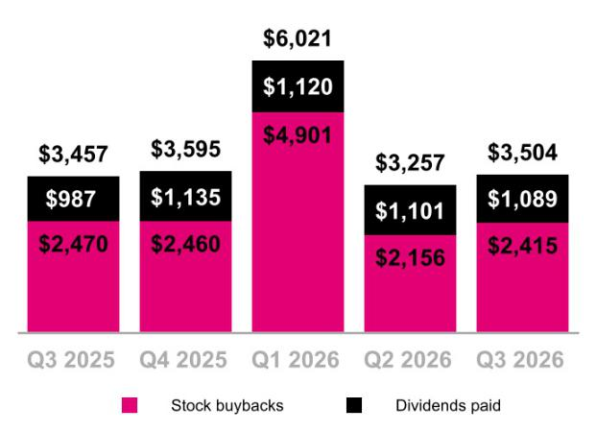

Total debt, excluding tower obligations, at the end of Q3 2026 was $86.0 billion.

Net debt, excluding tower obligations, at the end of Q3 2026 was $80.3 billion.

- On December 11, 2025, the company announced that its Board of Directors (the “Board”) authorized a stockholder return program for up to $14.6 billion that will run through December 31, 2026, consisting of additional repurchases of shares and payment of cash dividends.

  - On April 23, 2026, the company announced that the Board increased the company’s 2026 stockholder return authorization to up to $18.2 billion, representing an increase of up to $3.6 billion from its prior 2026 authorization.

  - During Q3 2026, the Board declared a cash dividend of $1.17 per share, an increase of $0.15 per share, or 15%. The dividend will be paid on December 10, 2026, to stockholders of record as of the close of business on November 25, 2026.

- On a cumulative basis, since the company initiated its stockholder return program in Q3 2022, a total of $58.1 billion has been returned to stockholders as of September 30, 2026, with 264.4 million shares repurchased for $46.7 billion, and cumulative cash dividends of $11.5 billion.

  - During Q3 2026, 13.6 million shares were repurchased for $2.4 billion.

  - During Q3 2026, the company paid a cash dividend of $1.02 per share of common stock, or $1.1 billion, on September 10, 2026.

- In Q4 2026, through October 23, 2026, the company repurchased an additional $791 million in common stock, totaling $3.2 billion in stock repurchased since the beginning of Q3 2026.

13

2026 Outlook

Metric | Previous | Revised | Change at Midpoint
Postpaid net account additions | 950 thousand to 1.05 | ~1.0 million | No change
Postpaid net account additions | million | ~1.0 million | No change
Net income ⁽¹⁾ | N/A | N/A | N/A
Effective tax rate | 25% to 26% | 24% to 25% | (100) bps
Core Adjusted EBITDA ⁽²⁾ | $37.1 to $37.5 billion | $37.35 to $37.45 billion | $100 million
Net cash provided by operating activities | $28.4 to $28.8 billion | $28.7 to $28.8 billion | $150 million
Capital expenditures ⁽³⁾ | ~$10.0 billion | ~$10.0 billion | No change
Adjusted Free Cash Flow | $18.4 to $18.8 billion | $18.7 to $18.8 billion | $150 million

- We are not able to forecast Net income on a forward-looking basis without unreasonable efforts due to the high variability and difficulty in predicting certain items that affect GAAP Net income, including, but not limited to, Special Items, Income tax expense and Interest expense. Core Adjusted EBITDA should not be used to predict Net income as the difference between this measure and Net income is variable.

- Management uses Core Adjusted EBITDA as a measure to monitor the financial performance of our operations, excluding the impact of lease revenues from our related device financing programs.
- Capital expenditures means cash purchases of property and equipment, including capitalized interest.

14

Investor Relations


Cathy Yao

Matthew Hale

Jon Lanterman

Senior Vice President


Senior Director


Senior Director


Charles Buffum

Chris Lo

Danna Tao

Aner Hezroni

Senior Manager

Manager

Manager

Senior Analyst

investor.relations@t-mobile.com

https://investor.t-mobile.com

 |  |  |  |  | 15
T-Mobile US, Inc.
Condensed Consolidated Balance Sheets
(Unaudited)
(in millions, except share and per share amounts) |  | September 30, |  |  | December 31,
(in millions, except share and per share amounts) |  | 2026 |  |  | 2025
Assets
Current assets
Cash and cash equivalents | $ | 5,620 | $ |  | 5,598
Accounts receivable, net of allowance for credit losses of $251 and $226 |  | 5,012 |  |  | 4,874
Equipment installment plan receivables, net of allowance for credit losses and unamortized discount of $723 and $733 |  | 4,530 |  |  | 4,997
Inventory |  | 3,085 |  |  | 2,405
Prepaid expenses |  | 909 |  |  | 1,215
Other current assets |  | 2,686 |  |  | 5,372
Total current assets |  | 21,842 |  |  | 24,461
Property and equipment, net |  | 36,035 |  |  | 38,333
Operating lease right-of-use assets |  | 24,208 |  |  | 25,692
Financing lease right-of-use assets |  | 2,987 |  |  | 2,760
Goodwill |  | 13,665 |  |  | 13,678
Spectrum licenses |  | 99,980 |  |  | 98,032
Other intangible assets, net |  | 3,066 |  |  | 3,843
Equipment installment plan receivables due after one year, net of allowance for credit losses and unamortized discount of $199 and $213 |  | 2,457 |  |  | 2,683
Other assets |  | 8,864 |  |  | 9,755
Total assets | $ | 213,104 |  | $ | 219,237
Liabilities and Stockholders' Equity
Current liabilities
Accounts payable and accrued liabilities | $ | 8,624 | $ |  | 10,280
Short-term debt |  | 6,343 |  |  | 5,135
Deferred revenue |  | 1,407 |  |  | 1,533
Short-term operating lease liabilities |  | 3,644 |  |  | 3,814
Short-term financing lease liabilities |  | 1,158 |  |  | 1,163
Other current liabilities |  | 2,815 |  |  | 2,575
Total current liabilities |  | 23,991 |  |  | 24,500
Long-term debt |  | 77,323 |  |  | 79,649
Long-term debt to affiliates |  | — |  |  | 1,498
Tower obligations |  | 3,419 |  |  | 3,532
Deferred tax liabilities |  | 21,715 |  |  | 19,583
Operating lease liabilities |  | 25,017 |  |  | 26,371
Financing lease liabilities |  | 1,136 |  |  | 1,107
Other long-term liabilities |  | 4,196 |  |  | 3,794
Total long-term liabilities |  | 132,806 |  |  | 135,534
Commitments and contingencies
Stockholders' equity
Common stock, par value $0.00001 per share, 2,000,000,000 shares authorized; 1,280,056,882 and 1,275,774,235 shares issued, |  | — |  |  | —
1,062,845,266 and 1,106,930,661 shares outstanding |  | — |  |  | —
Additional paid-in capital |  | 70,089 |  |  | 69,460
Treasury stock, at cost, 217,211,616 and 168,843,574 shares issued |  | (40,102) |  |  | (30,545)
Accumulated other comprehensive loss |  | (595) |  |  | (848)
Retained earnings |  | 26,915 |  |  | 21,136
Total stockholders' equity |  | 56,307 |  |  | 59,203
Total liabilities and stockholders' equity | $ | 213,104 |  | $ | 219,237

 |  |  |  |  |  |  |  |  |  |  |  |  |  | 16
 |  | T-Mobile US, Inc.
Condensed Consolidated Statements of Comprehensive Income
 |  | (Unaudited)
 |  |  | Three Months Ended |  |  |  |  |  |  |  | Nine Months Ended September 30,
(in millions, except share and per share amounts) |  | September 30, |  |  | June 30, |  |  | September 30, |  |  | 2026 |  |  | 2025
(in millions, except share and per share amounts) |  | 2026 |  |  | 2026 |  |  | 2025 |  |  | 2026 |  |  | 2025
Revenues
Postpaid revenues | $ | 16,269 | $ |  | 15,853 |  | $ | 14,882 |  | $ | 47,751 | $ |  | 42,554
Prepaid revenues |  | 2,427 |  |  | 2,473 |  |  | 2,625 |  |  | 7,417 |  |  | 7,911
Wholesale and other service revenues |  | 679 |  |  | 657 |  |  | 734 |  |  | 2,021 |  |  | 2,139
Total service revenues |  | 19,375 |  |  | 18,983 |  |  | 18,241 |  |  | 57,189 |  |  | 52,604
Equipment revenues |  | 3,929 |  |  | 3,524 |  |  | 3,465 |  |  | 11,449 |  |  | 10,608
Other revenues |  | 280 |  |  | 284 |  |  | 251 |  |  | 844 |  |  | 763
Total revenues |  | 23,584 |  |  | 22,791 |  |  | 21,957 |  |  | 69,482 |  |  | 63,975
Operating expenses
Cost of services, exclusive of depreciation and amortization shown separately |  | 3,007 |  |  | 2,978 |  |  | 2,873 |  |  | 9,324 |  |  | 8,192
below |  | 3,007 |  |  | 2,978 |  |  | 2,873 |  |  | 9,324 |  |  | 8,192
Cost of equipment sales, exclusive of depreciation and amortization shown |  | 5,444 |  |  | 5,055 |  |  | 4,853 |  |  | 15,987 |  |  | 14,310
separately below |  | 5,444 |  |  | 5,055 |  |  | 4,853 |  |  | 15,987 |  |  | 14,310
Selling, general and administrative |  | 6,020 |  |  | 5,834 |  |  | 6,015 |  |  | 17,820 |  |  | 16,900
Impairment expense |  | — |  |  | — |  |  | 278 |  |  | — |  |  | 278
Depreciation and amortization |  | 3,452 |  |  | 3,434 |  |  | 3,408 |  |  | 10,703 |  |  | 9,752
Total operating expenses |  | 17,923 |  |  | 17,301 |  |  | 17,427 |  |  | 53,834 |  |  | 49,432
Operating income |  | 5,661 |  |  | 5,490 |  |  | 4,530 |  |  | 15,648 |  |  | 14,543
Other expense, net
Interest expense, net |  | (1,031) |  |  | (1,055) |  |  | (924) |  |  | (3,117) |  |  | (2,762)
Other expense, net |  | (90) |  |  | (107) |  |  | (78) |  |  | (329) |  |  | (135)
Total other expense, net |  | (1,121) |  |  | (1,162) |  |  | (1,002) |  |  | (3,446) |  |  | (2,897)
Income before income taxes |  | 4,540 |  |  | 4,328 |  |  | 3,528 |  |  | 12,202 |  |  | 11,646
Income tax expense |  | (1,085) |  |  | (1,089) |  |  | (814) |  |  | (3,004) |  |  | (2,757)
Net income | $ | 3,455 | $ |  | 3,239 |  | $ | 2,714 |  | $ | 9,198 | $ |  | 8,889
Net income | $ | 3,455 | $ |  | 3,239 |  | $ | 2,714 |  | $ | 9,198 | $ |  | 8,889
Other comprehensive income (loss), net of tax
Reclassification of loss from cash flow hedges, net of tax effect of $18, $17, |  | 52 |  |  | 50 |  |  | 48 |  |  | 152 |  |  | 141
$16, $52 and $48 |  | 52 |  |  | 50 |  |  | 48 |  |  | 152 |  |  | 141
Gains (losses) on fair value hedges, net of tax effect of $9, $48, $(7), $45 and |  | 27 |  |  | 142 |  |  | (20) |  |  | 133 |  |  | (160)
$(55) |  | 27 |  |  | 142 |  |  | (20) |  |  | 133 |  |  | (160)
Unrealized gain (loss) on foreign currency translation adjustment, net of tax |  | 1 |  |  | 9 |  |  | — |  |  | 10 |  |  | (1)
effect of $1, $0, $0, $1 and $0 |  | 1 |  |  | 9 |  |  |  |  |  | 10 |  |  | (1)
Prior service cost, net of amortization, and amortization of actuarial gain, on
pension and other postretirement benefits, net of tax effect of $(13), $(1), $0, |  | (40) |  |  | (1) |  |  | (1) |  |  | (42) |  |  | (4)
$(14) and $(1) |  | (40) |  |  | (1) |  |  | (1) |  |  | (42) |  |  | (4)
Other comprehensive income (loss) |  | 40 |  |  | 200 |  |  | 27 |  |  | 253 |  |  | (24)
Total comprehensive income | $ | 3,495 |  | $ | 3,439 |  | $ | 2,741 |  | $ | 9,451 |  | $ | 8,865
Earnings per share
Basic | $ | 3.23 | $ |  | 2.99 |  | $ | 2.42 |  | $ | 8.49 | $ |  | 7.84
Diluted | $ | 3.22 | $ |  | 2.99 |  | $ | 2.41 |  | $ | 8.47 | $ |  | 7.82
Weighted-average shares outstanding
Basic |  | 1,070,648,134 |  |  | 1,081,771,279 |  |  | 1,123,754,096 |  |  | 1,084,089,790 |  |  | 1,133,743,367
Diluted |  | 1,071,630,434 |  |  | 1,082,409,636 |  |  | 1,126,627,708 |  |  | 1,085,476,683 |  |  | 1,136,920,521

 |  |  |  |  |  |  |  |  |  |  |  |  |  | 17
 |  | T-Mobile US, Inc.
Condensed Consolidated Statements of Cash Flows
 |  | (Unaudited)
 |  |  | Three Months Ended |  |  |  |  |  |  |  | Nine Months Ended September 30,
(in millions) |  | September 30, |  |  | June 30, |  |  | September 30, |  |  | 2026 |  |  | 2025
(in millions) |  | 2026 |  |  | 2026 |  |  | 2025 |  |  | 2026 |  |  | 2025
Operating activities
Net income | $ | 3,455 | $ |  | 3,239 |  | $ | 2,714 | $ |  | 9,198 | $ |  | 8,889
Adjustments to reconcile net income to net cash provided by operating
activities
Depreciation and amortization |  | 3,452 |  |  | 3,434 |  |  | 3,408 |  |  | 10,703 |  |  | 9,752
Stock-based compensation expense |  | 197 |  |  | 214 |  |  | 227 |  |  | 620 |  |  | 613
Deferred income tax expense |  | 637 |  |  | 893 |  |  | 797 |  |  | 2,212 |  |  | 2,505
Bad debt expense |  | 437 |  |  | 398 |  |  | 337 |  |  | 1,261 |  |  | 925
Losses from sales of receivables |  | 15 |  |  | 17 |  |  | 17 |  |  | 52 |  |  | 58
Impairment expense |  | — |  |  | — |  |  | 278 |  |  | — |  |  | 278
Changes in operating assets and liabilities
Accounts receivable |  | (9) |  |  | (498) |  |  | (366) |  |  | (669) |  |  | (797)
Equipment installment plan receivables |  | (9) |  |  | 103 |  |  | 44 |  |  | 39 |  |  | 133
Inventory |  | (892) |  |  | 142 |  |  | (537) |  |  | (664) |  |  | (591)
Operating lease right-of-use assets |  | 969 |  |  | 965 |  |  | 929 |  |  | 3,130 |  |  | 2,667
Other current and long-term assets |  | (122) |  |  | (354) |  |  | (322) |  |  | (443) |  |  | (983)
Accounts payable and accrued liabilities |  | (421) |  |  | (265) |  |  | 890 |  |  | (1,094) |  |  | 729
Short- and long-term operating lease liabilities |  | (979) |  |  | (976) |  |  | (936) |  |  | (3,173) |  |  | (2,720)
Other current and long-term liabilities |  | 334 |  |  | (3) |  |  | (239) |  |  | 222 |  |  | (409)
Other, net |  | 277 |  |  | 191 |  |  | 216 |  |  | 669 |  |  | 247
Net cash provided by operating activities |  | 7,341 |  |  | 7,500 |  |  | 7,457 |  |  | 22,063 |  |  | 21,296
Investing activities
Purchases of property and equipment, including capitalized interest of $(7), |  | (2,270) |  |  | (2,703) |  |  | (2,639) |  |  | (7,596) |  |  | (7,486)
$(6), $(13), $(20) and $(33) |  | (2,270) |  |  | (2,703) |  |  | (2,639) |  |  | (7,596) |  |  | (7,486)
Purchases of spectrum licenses and other intangible assets, including deposits |  | (324) |  |  | (484) |  |  | (1,590) |  |  | (834) |  |  | (2,505)
Proceeds from the sale of property, equipment and intangible assets |  | 2,927 |  |  | 16 |  |  | 18 |  |  | 3,038 |  |  | 2,091
Acquisition of companies, net of cash acquired |  | — |  |  | — |  |  | (2,797) |  |  | (1) |  |  | (3,523)
Investments in unconsolidated affiliates, net |  | 4 |  |  | (3) |  |  | (3,072) |  |  | 1 |  |  | (4,055)
Other, net |  | 21 |  |  | 122 |  |  | (59) |  |  | (151) |  |  | 371
Net cash provided by (used in) investing activities |  | 358 |  |  | (3,052) |  |  | (10,139) |  |  | (5,543) |  |  | (15,107)
Financing activities
Proceeds from issuance of long-term debt, net |  | 498 |  |  | (5) |  |  | 498 |  |  | 6,891 |  |  | 8,266
Repayments of financing lease obligations |  | (331) |  |  | (360) |  |  | (318) |  |  | (995) |  |  | (964)
Repayments of long-term debt |  | (1,367) |  |  | (1,336) |  |  | (828) |  |  | (9,138) |  |  | (4,564)
Repurchases of common stock |  | (2,418) |  |  | (2,320) |  |  | (2,479) |  |  | (9,564) |  |  | (7,528)
Dividends on common stock |  | (1,089) |  |  | (1,101) |  |  | (987) |  |  | (3,310) |  |  | (2,986)
Tax withholdings on share-based awards |  | (86) |  |  | (31) |  |  | (92) |  |  | (271) |  |  | (394)
Other, net |  | (55) |  |  | (29) |  |  | (32) |  |  | (83) |  |  | (80)
Net cash used in financing activities |  | (4,848) |  |  | (5,182) |  |  | (4,238) |  |  | (16,470) |  |  | (8,250)
Effect of exchange rate changes on cash and cash equivalents, including |  | — |  |  | — |  |  | — |  |  | — |  |  | 13
restricted cash |  | — |  |  | — |  |  | — |  |  | — |  |  | 13
Change in cash and cash equivalents, including restricted cash |  | 2,851 |  |  | (734) |  |  | (6,920) |  |  | 50 |  |  | (2,048)
Cash and cash equivalents, including restricted cash
Beginning of period |  | 3,175 |  |  | 3,909 |  |  | 10,585 |  |  | 5,976 |  |  | 5,713
End of period | $ | 6,026 |  | $ | 3,175 |  | $ | 3,665 |  | $ | 6,026 |  | $ | 3,665

 |  |  |  |  |  |  |  |  |  |  |  |  |  | 18
 |  | T-Mobile US, Inc.
Condensed Consolidated Statements of Cash Flows (Continued)
 |  | (Unaudited)
 |  |  | Three Months Ended |  |  |  |  |  |  |  | Nine Months Ended September 30,
(in millions) |  | September 30, |  |  | June 30, |  |  | September 30, |  |  | 2026 |  |  | 2025
(in millions) |  | 2026 |  |  | 2026 |  |  | 2025 |  |  | 2026 |  |  | 2025
Supplemental disclosure of cash flow information
Interest payments, net of amounts capitalized | $ | 946 | $ |  | 1,119 |  | $ | 997 | $ |  | 3,119 | $ |  | 2,923
Operating lease payments |  | 1,302 |  |  | 1,303 |  |  | 1,269 |  |  | 4,142 |  |  | 3,685
Income tax payments, net of refunds received |  | 7 |  |  | 757 |  |  | 63 |  |  | 774 |  |  | 415
Non-cash investing and financing activities
Change in accounts payable and accrued liabilities for purchases of property | $ | 51 | $ |  | (404) |  | $ | 136 | $ |  | (710) | $ |  | (458)
and equipment
Operating lease right-of-use assets obtained in exchange for lease obligations |  | 582 |  |  | 540 |  |  | 1,064 |  |  | 1,647 |  |  | 2,138
Financing lease right-of-use assets obtained in exchange for lease obligations |  | 340 |  |  | 488 |  |  | 324 |  |  | 1,050 |  |  | 1,002
Debt assumed in the UScellular Acquisition |  | — |  |  | — |  |  | 1,653 |  |  | — |  |  | 1,653

 |  |  |  |  |  |  |  |  |  |  |  |  |  |  |  | 19
 |  |  | T-Mobile US, Inc.
 | Supplementary Operating and Financial Data
 |  |  | (Unaudited)
 |  |  |  |  |  |  | Quarter |  |  |  |  |  |  |  | Nine Months Ended
 |  |  |  |  |  |  | Quarter |  |  |  |  |  |  |  | September 30,
(in thousands) | Q1 2025 |  | Q2 2025 |  | Q3 2025 |  | Q4 2025 |  | Q1 2026 |  | Q2 2026 |  | Q3 2026 |  | 2025 |  | 2026
Accounts, end of period
Total postpaid accounts ⁽¹⁾ ⁽²⁾ ⁽³⁾ ⁽⁴⁾ ⁽⁵⁾ | 31,099 | 31,502 |  | 33,979 |  |  | 34,240 | 34,439 |  | 34,700 |  | 34,974 |  | 33,979 |  | 34,974

- In the second quarter of 2025, we acquired 85,000 postpaid accounts from Lumos.

- In the third quarter of 2025, we acquired 633,000 postpaid accounts from Metronet and other acquisitions.
- In the third quarter of 2025, we acquired 1,448,000 postpaid accounts through the UScellular acquisition, which includes the impact of certain base adjustments to align the policies of UScellular and T-Mobile.
- In the first quarter of 2026, we recognized a base adjustment to decrease postpaid accounts by 18,000, primarily due to combining certain business accounts that have multiple billing account numbers.
- In the second quarter of 2026, Metronet agreed to repurchase certain customer accounts, resulting in a base adjustment to decrease postpaid accounts by 16,000.

These base adjustments had no impact on postpaid net account additions.

 |  |  |  |  |  |  |  |  |  |  |  |  |  |  |  |  |  |  |  |  |  | Quarter |  |  |  |  |  |  |  |  |  |  |  |  |  |  |  |  |  |  |  |  |  |  | Nine Months Ended
 |  |  |  |  |  |  |  |  |  |  |  |  |  |  |  |  |  |  |  |  |  |  |  |  |  |  |  |  |  |  |  |  |  |  |  |  |  |  |  |  |  |  |  |  | September 30,
 | (in thousands) |  | Q1 2025 |  |  |  |  |  |  | Q2 2025 |  |  |  |  |  | Q3 2025 |  |  |  |  |  | Q4 2025 |  |  |  |  |  | Q1 2026 |  |  |  |  |  |  | Q2 2026 |  |  |  |  | Q3 2026 |  |  |  |  | 2025 |  |  |  | 2026
 | Net account additions
 | Postpaid net account additions |  |  | 205 |  |  |  |  |  |  | 318 |  |  |  |  | 396 |  |  |  |  |  | 261 |  |  |  |  |  | 217 |  |  |  |  |  |  | 277 |  |  |  |  | 274 |  |  |  |  | 919 |  |  |  | 768
 |  |  |  |  |  |  |  |  |  |  |  |  |  |  |  |  |  |  |  | Quarter |  |  |  |  |  |  |  |  |  |  |  |  |  |  |  |  |  |  |  |  |  |  |  |  | Nine Months Ended
 |  |  |  |  |  |  |  |  |  |  |  |  |  |  |  |  |  |  |  |  |  |  |  |  |  |  |  |  |  |  |  |  |  |  |  |  |  |  |  |  |  |  |  |  | September 30,
 |  | Q1 2025 |  |  |  | Q2 2025 |  |  |  |  |  | Q3 2025 |  |  |  |  |  |  |  | Q4 2025 |  |  |  |  |  | Q1 2026 |  |  |  |  |  |  | Q2 2026 |  |  |  |  | Q3 2026 |  |  |  |  |  |  | 2025 |  |  |  | 2026
 | Churn
 | Postpaid account churn | 0.94 % |  |  |  |  |  | 0.92 % |  |  |  |  |  | 0.97 % |  |  |  |  |  | 1.04 % |  |  |  |  |  |  |  | 1.04 % |  |  |  |  |  |  | 0.99 % |  |  |  |  | 1.09 % |  |  |  |  | 0.94 % |  |  |  | 1.04 %
 |  |  |  |  |  |  |  |  |  |  |  |  |  |  |  |  |  |  |  |  |  | Quarter |  |  |  |  |  |  |  |  |  |  |  |  |  |  |  |  |  |  |  |  |  |  | Nine Months Ended
 |  |  |  |  |  |  |  |  |  |  |  |  |  |  |  |  |  |  |  |  |  |  |  |  |  |  |  |  |  |  |  |  |  |  |  |  |  |  |  |  |  |  |  |  | September 30,
 |  |  | Q1 2025 |  |  |  |  |  |  | Q2 2025 |  |  |  |  |  | Q3 2025 |  |  |  |  |  | Q4 2025 |  |  |  |  |  | Q1 2026 |  |  |  |  |  |  | Q2 2026 |  |  |  |  | Q3 2026 |  |  |  |  | 2025 |  |  |  | 2026
 | Operating measure
 | Postpaid ARPA | $ |  | 146.22 |  |  |  | $ |  | 149.87 |  |  |  | $ |  | 149.44 |  |  |  | $ |  | 150.17 |  |  |  | $ |  | 151.93 |  |  |  |  | $ |  | 152.91 |  |  | $ |  | 155.73 |  |  | $ |  | 148.54 |  | $ |  | 153.53
 |  |  |  |  |  |  |  |  |  |  |  |  |  |  |  |  |  |  |  | Quarter |  |  |  |  |  |  |  |  |  |  |  |  |  |  |  |  |  |  |  |  |  |  |  |  | Nine Months Ended
 |  |  |  |  |  |  |  |  |  |  |  |  |  |  |  |  |  |  |  |  |  |  |  |  |  |  |  |  |  |  |  |  |  |  |  |  |  |  |  |  |  |  |  |  | September 30,
 |  | Q1 2025 |  |  |  | Q2 2025 |  |  |  |  |  | Q3 2025 |  |  |  |  |  |  |  | Q4 2025 |  |  |  |  |  | Q1 2026 |  |  |  |  |  |  | Q2 2026 |  |  |  |  |  | Q3 2026 |  |  |  |  |  | 2025 |  |  |  | 2026
 | Postpaid upgrade rate
 | Postpaid device upgrade rate | 2.8 % |  |  |  |  |  | 2.5 % |  |  |  |  |  |  |  | 2.7 % |  |  |  |  |  | 3.8 % |  |  |  |  |  | 2.8 % |  |  |  |  |  |  | 2.6 % |  |  |  |  | 2.8 % |  |  |  |  | 8.0 % |  |  |  | 8.3 %
 |  |  |  |  |  |  |  |  |  |  |  |  |  |  |  |  |  |  |  |  |  | Quarter |  |  |  |  |  |  |  |  |  |  |  |  |  |  |  |  |  |  |  |  |  |  | Nine Months Ended
 |  |  |  |  |  |  |  |  |  |  |  |  |  |  |  |  |  |  |  |  |  |  |  |  |  |  |  |  |  |  |  |  |  |  |  |  |  |  |  |  |  |  |  |  | September 30,
 | (in millions) |  | Q1 2025 |  |  |  |  |  |  | Q2 2025 |  |  |  |  |  | Q3 2025 |  |  |  |  |  | Q4 2025 |  |  |  |  |  | Q1 2026 |  |  |  |  |  |  | Q2 2026 |  |  |  |  | Q3 2026 |  |  |  |  | 2025 |  |  |  | 2026
 | Device financing - equipment installment plans
 | Gross EIP financed | $ |  | 3,565 |  |  |  | $ |  |  | 3,503 |  |  | $ |  | 3,871 |  |  |  | $ |  | 5,774 |  |  |  | $ |  | 4,322 |  |  |  |  | $ |  | 3,958 |  |  | $ |  | 4,576 |  |  | $ |  | 10,939 |  | $ |  | 12,856
 | EIP billings |  |  | 3,551 |  |  |  |  |  |  | 3,553 |  |  |  |  | 3,766 |  |  |  |  |  | 4,066 |  |  |  |  |  | 4,167 |  |  |  |  |  |  | 4,132 |  |  |  |  | 4,303 |  |  |  |  | 10,870 |  |  |  | 12,602
 | EIP receivables, net |  |  | 6,405 |  |  |  |  |  |  | 6,201 |  |  |  |  | 6,915 |  |  |  |  |  | 7,680 |  |  |  |  |  | 7,488 |  |  |  |  |  |  | 7,173 |  |  |  |  | 6,987 |  |  |  |  | 6,915 |  |  |  | 6,987
 | Device financing - leased devices
 | Lease revenues | $ |  | 1 |  |  |  | $ |  |  | 6 |  |  | $ |  | 4 |  |  |  | $ |  | 2 |  |  |  | $ |  | 1 |  |  |  |  | $ |  | — |  |  | $ |  | — |  |  | $ |  | 11 |  | $ |  | 1
 | Leased device depreciation |  |  | 4 |  |  |  |  |  |  | 1 |  |  |  |  |  |  |  | — |  |  |  |  | — |  |  |  |  | — |  |  |  |  |  | — |  |  |  |  | — |  |  |  |  | 5 |  |  |  | —

 |  |  |  |  |  |  |  |  |  |  |  |  |  |  |  |  |  |  |  |  |  |  |  |  |  | 20
 |  |  |  |  |  |  |  | T-Mobile US, Inc.
 |  | Supplementary Operating and Financial Data (continued)
 |  |  |  |  |  |  |  | (Unaudited)
 |  |  |  |  |  |  |  |  |  |  | Quarter |  |  |  |  |  |  |  |  |  |  |  | Nine Months Ended
 |  |  |  |  |  |  |  |  |  |  | Quarter |  |  |  |  |  |  |  |  |  |  |  | September 30,
(in millions, except percentages) |  | Q1 2025 |  |  | Q2 2025 |  |  | Q3 2025 |  |  | Q4 2025 |  |  | Q1 2026 |  |  | Q2 2026 |  |  | Q3 2026 |  |  | 2025 |  |  | 2026
Financial measures
Service revenues | $ | 16,925 | $ |  | 17,438 | $ |  | 18,241 | $ |  | 18,702 | $ |  | 18,831 | $ |  | 18,983 | $ |  | 19,375 | $ |  | 52,604 | $ |  | 57,189
Equipment revenues | $ | 3,704 | $ |  | 3,439 | $ |  | 3,465 | $ |  | 5,364 | $ |  | 3,996 | $ |  | 3,524 | $ |  | 3,929 | $ |  | 10,608 | $ |  | 11,449
Lease revenues |  | 1 |  |  | 6 |  |  | 4 |  |  | 2 |  |  | 1 |  |  | — |  |  | — |  |  | 11 |  |  | 1
Equipment sales | $ | 3,703 | $ |  | 3,433 | $ |  | 3,461 | $ |  | 5,362 | $ |  | 3,995 | $ |  | 3,524 | $ |  | 3,929 | $ |  | 10,597 | $ |  | 11,448
Total revenues | $ | 20,886 | $ |  | 21,132 | $ |  | 21,957 | $ |  | 24,334 | $ |  | 23,107 | $ |  | 22,791 | $ |  | 23,584 | $ |  | 63,975 | $ |  | 69,482
Net income | $ | 2,953 | $ |  | 3,222 | $ |  | 2,714 | $ |  | 2,103 | $ |  | 2,504 | $ |  | 3,239 | $ |  | 3,455 | $ |  | 8,889 | $ |  | 9,198
Net income margin |  | 17.4 % |  |  | 18.5 % |  |  | 14.9 % |  |  | 11.2 % |  |  | 13.3 % |  |  | 17.1 % |  |  | 17.8 % |  |  | 16.9 % |  |  | 16.1 %
Adjusted EBITDA | $ | 8,259 | $ |  | 8,547 | $ |  | 8,684 | $ |  | 8,447 | $ |  | 9,241 | $ |  | 9,537 | $ |  | 9,620 | $ |  | 25,490 | $ |  | 28,398
Adjusted EBITDA margin |  | 48.8 % |  |  | 49.0 % |  |  | 47.6 % |  |  | 45.2 % |  |  | 49.1 % |  |  | 50.2 % |  |  | 49.7 % |  |  | 48.5 % |  |  | 49.7 %
Core Adjusted EBITDA | $ | 8,258 | $ |  | 8,541 | $ |  | 8,680 | $ |  | 8,445 | $ |  | 9,240 | $ |  | 9,537 | $ |  | 9,620 | $ |  | 25,479 | $ |  | 28,397
Core Adjusted EBITDA margin |  | 48.8 % |  |  | 49.0 % |  |  | 47.6 % |  |  | 45.2 % |  |  | 49.1 % |  |  | 50.2 % |  |  | 49.7 % |  |  | 48.4 % |  |  | 49.7 %
Cost of services, exclusive of depreciation and | $ | 2,602 | $ |  | 2,717 | $ |  | 2,873 | $ |  | 3,305 | $ |  | 3,339 | $ |  | 2,978 | $ |  | 3,007 | $ |  | 8,192 | $ |  | 9,324
amortization
UScellular merger-related costs |  | — |  |  | — |  |  | 7 |  |  | 24 |  |  | 344 |  |  | 44 |  |  | 22 |  |  | 7 |  |  | 410
Other Special Items |  | 20 |  |  | 28 |  |  | 55 |  |  | 250 |  |  | 101 |  |  | 69 |  |  | 46 |  |  | 103 |  |  | 216
Cost of services, exclusive of depreciation and | $ | 2,582 |  | $ | 2,689 |  | $ | 2,811 |  | $ | 3,031 |  | $ | 2,894 |  | $ | 2,865 |  | $ | 2,939 |  | $ | 8,082 |  | $ | 8,698
amortization and Special Items
Cost of equipment sales, exclusive of | $ | 4,798 | $ |  | 4,659 | $ |  | 4,853 | $ |  | 6,967 | $ |  | 5,488 | $ |  | 5,055 | $ |  | 5,444 | $ |  | 14,310 | $ |  | 15,987
depreciation and amortization
UScellular merger-related costs |  | — |  |  | — |  |  | 2 |  |  | 8 |  |  | 14 |  |  | 23 |  |  | 2 |  |  | 2 |  |  | 39
Other Special Items |  | — |  |  | — |  |  | — |  |  | — |  |  | 8 |  |  | — |  |  | — |  |  | — |  |  | 8
Cost of equipment sales, exclusive of | $ | 4,798 | $ |  | 4,659 | $ |  | 4,851 | $ |  | 6,959 | $ |  | 5,466 | $ |  | 5,032 | $ |  | 5,442 | $ |  | 14,308 | $ |  | 15,940
depreciation and amortization and Special Items
Selling, general and administrative | $ | 5,488 | $ |  | 5,397 | $ |  | 6,015 | $ |  | 6,570 | $ |  | 5,966 | $ |  | 5,834 | $ |  | 6,020 | $ |  | 16,900 | $ |  | 17,820
UScellular merger-related costs |  | 14 |  |  | 33 |  |  | 64 |  |  | 111 |  |  | 48 |  |  | 115 |  |  | 105 |  |  | 111 |  |  | 268
Other Special Items |  | 59 |  |  | (51) |  |  | 123 |  |  | 353 |  |  | 209 |  |  | 150 |  |  | 137 |  |  | 131 |  |  | 496
Selling, general and administrative, excluding | $ | 5,415 |  | $ | 5,415 |  | $ | 5,828 |  | $ | 6,106 |  | $ | 5,709 |  | $ | 5,569 |  | $ | 5,778 |  | $ | 16,658 |  | $ | 17,056
Special Items
Total bad debt expense and losses from sales of | $ | 345 | $ |  | 284 | $ |  | 354 | $ |  | 445 | $ |  | 446 | $ |  | 415 | $ |  | 452 | $ |  | 983 | $ |  | 1,313
receivables
Bad debt and losses from sales of receivables as |  | 1.7 % |  |  | 1.3 % |  |  | 1.6 % |  |  | 1.8 % |  |  | 1.9 % |  |  | 1.8 % |  |  | 1.9 % |  |  | 1.5 % |  |  | 1.9 %
a percentage of Total revenues |  | 1.7 % |  |  | 1.3 % |  |  | 1.6 % |  |  | 1.8 % |  |  | 1.9 % |  |  | 1.8 % |  |  | 1.9 % |  |  | 1.5 % |  |  | 1.9 %
Cash purchases of property and equipment | $ | 2,451 | $ |  | 2,396 | $ |  | 2,639 | $ |  | 2,469 | $ |  | 2,623 | $ |  | 2,703 | $ |  | 2,270 | $ |  | 7,486 | $ |  | 7,596
including capitalized interest
Capitalized interest |  | 10 |  |  | 10 |  |  | 13 |  |  | 10 |  |  | 7 |  |  | 6 |  |  | 7 |  |  | 33 |  |  | 20
Net cash proceeds from securitization | $ | (26) | $ |  | (23) | $ |  | (25) | $ |  | (22) | $ |  | (20) | $ |  | (22) | $ |  | (20) | $ |  | (74) | $ |  | (62)
Net payments for Merger-related costs | $ | 70 | $ |  | 92 | $ |  | 96 | $ |  | 100 | $ |  | 153 | $ |  | 181 | $ |  | 198 | $ |  | 258 | $ |  | 532

 |  |  |  |  |  |  |  |  |  |  |  |  |  |  |  |  |  |  |  |  |  |  |  |  |  |  | 21
 |  |  |  |  |  | T-Mobile US, Inc.
 | Supplementary Operating and Financial Data (Continued)
 |  |  |  |  |  |  | (Unaudited)
 |  |  |  |  |  |  |  |  |  |  |  | Quarter |  |  |  |  |  |  |  |  |  |  |  | Nine Months Ended
 |  |  |  |  |  |  |  |  |  |  |  | Quarter |  |  |  |  |  |  |  |  |  |  |  | September 30,
(in millions, except share and per share amounts) |  |  | Q1 2025 |  |  | Q2 2025 |  |  | Q3 2025 |  |  | Q4 2025 |  |  | Q1 2026 |  |  | Q2 2026 |  |  | Q3 2026 |  |  | 2025 |  |  | 2026
Stockholder returns
Total repurchases | $ |  | 2,470 | $ |  | 2,469 | $ |  | 2,470 | $ |  | 2,460 | $ |  | 4,901 | $ |  | 2,156 | $ |  | 2,415 | $ |  | 7,409 | $ |  | 9,472
Total shares repurchased |  |  | 10,091,227 |  |  | 10,148,791 |  |  | 10,204,072 |  |  | 11,919,136 |  |  | 23,329,925 |  |  | 11,420,845 |  |  | 13,621,695 |  |  | 30,444,090 |  |  | 48,372,465
Average purchase price per share | $ |  | 244.77 | $ |  | 243.32 | $ |  | 242.01 | $ |  | 206.38 | $ |  | 210.07 | $ |  | 188.76 | $ |  | 177.31 | $ |  | 243.36 | $ |  | 195.81
Total dividends paid | $ |  | 1,003 | $ |  | 996 | $ |  | 987 | $ |  | 1,135 | $ |  | 1,120 | $ |  | 1,101 | $ |  | 1,089 | $ |  | 2,986 | $ |  | 3,310
Dividends per share | $ |  | 0.88 | $ |  | 0.88 | $ |  | 0.88 | $ |  | 1.02 | $ |  | 1.02 | $ |  | 1.02 | $ |  | 1.02 | $ |  | 2.64 | $ |  | 3.06
Total stockholder returns | $ |  | 3,473 | $ |  | 3,465 | $ |  | 3,457 | $ |  | 3,595 | $ |  | 6,021 | $ |  | 3,257 | $ |  | 3,504 | $ |  | 10,395 | $ |  | 12,782
Cumulative total repurchases | $ |  | 29,785 | $ |  | 32,254 | $ |  | 34,724 | $ |  | 37,184 | $ |  | 42,085 | $ |  | 44,241 | $ |  | 46,656 | $ |  | 34,724 | $ |  | 46,656
Cumulative shares repurchased |  |  | 183,754,602 |  |  | 193,903,393 |  |  | 204,107,465 |  |  | 216,026,601 |  |  | 239,356,526 |  |  | 250,777,371 |  |  | 264,399,066 |  |  | 204,107,465 |  |  | 264,399,066
Cumulative stockholder returns | $ |  | 34,835 | $ |  | 38,300 | $ |  | 41,757 | $ |  | 45,352 | $ |  | 51,373 | $ |  | 54,630 | $ |  | 58,134 | $ |  | 41,757 | $ |  | 58,134

22

T-Mobile US, Inc.

Reconciliation of Non-GAAP Financial Measures to GAAP Financial Measures

(Unaudited)

This Investor Factbook includes non-GAAP financial measures, including Adjusted EBITDA, Core Adjusted EBITDA, Net Debt, Adjusted Free Cash Flow and Adjusted Free Cash Flow margin. The non-GAAP financial measures should be considered in addition to, but not as a substitute for, the information provided in accordance with GAAP. Reconciliations for the non-GAAP financial measures to the most directly comparable GAAP financial measures are provided below. T-Mobile is not able to forecast Net income on a forward-looking basis without unreasonable efforts due to the high variability and difficulty in predicting certain items that affect GAAP Net income, including, but not limited to, Special Items, Income tax expense and Interest expense. Adjusted EBITDA and Core Adjusted EBITDA should not be used to predict Net income, as the difference between either of these measures and Net income is variable.

Adjusted EBITDA and Core Adjusted EBITDA are reconciled to Net income as follows:

 |  |  |  |  |  |  |  |  |  |  | Quarter |  |  |  |  |  |  |  |  |  |  |  | Nine Months Ended
 |  |  |  |  |  |  |  |  |  |  | Quarter |  |  |  |  |  |  |  |  |  |  |  | September 30,
(in millions, except percentages) |  | Q1 2025 |  |  | Q2 2025 |  |  | Q3 2025 |  |  | Q4 2025 |  |  | Q1 2026 |  |  | Q2 2026 |  |  | Q3 2026 |  |  | 2025 |  |  | 2026
Net income | $ | 2,953 | $ |  | 3,222 | $ |  | 2,714 | $ |  | 2,103 | $ |  | 2,504 | $ |  | 3,239 | $ |  | 3,455 | $ |  | 8,889 | $ |  | 9,198
Adjustments:
Interest expense, net |  | 916 |  |  | 922 |  |  | 924 |  |  | 1,012 |  |  | 1,031 |  |  | 1,055 |  |  | 1,031 |  |  | 2,762 |  |  | 3,117
Other expense, net |  | 46 |  |  | 11 |  |  | 78 |  |  | 89 |  |  | 132 |  |  | 107 |  |  | 90 |  |  | 135 |  |  | 329
Income tax expense |  | 885 |  |  | 1,058 |  |  | 814 |  |  | 532 |  |  | 830 |  |  | 1,089 |  |  | 1,085 |  |  | 2,757 |  |  | 3,004
Operating income |  | 4,800 |  |  | 5,213 |  |  | 4,530 |  |  | 3,736 |  |  | 4,497 |  |  | 5,490 |  |  | 5,661 |  |  | 14,543 |  |  | 15,648
Depreciation and amortization |  | 3,198 |  |  | 3,146 |  |  | 3,408 |  |  | 3,756 |  |  | 3,817 |  |  | 3,434 |  |  | 3,452 |  |  | 9,752 |  |  | 10,703
Stock-based compensation ⁽¹⁾ |  | 168 |  |  | 178 |  |  | 217 |  |  | 209 |  |  | 203 |  |  | 212 |  |  | 195 |  |  | 563 |  |  | 610
UScellular merger-related costs |  | 14 |  |  | 33 |  |  | 73 |  |  | 143 |  |  | 406 |  |  | 182 |  |  | 129 |  |  | 120 |  |  | 717
Network restructuring initiative costs ⁽²⁾ |  | — |  |  | — |  |  | — |  |  | 93 |  |  | 76 |  |  | 52 |  |  | 38 |  |  | — |  |  | 166
Legal-related expenses (recoveries), net ⁽³⁾ |  | 6 |  |  | (4) |  |  | 8 |  |  | 6 |  |  | 54 |  |  | 16 |  |  | 14 |  |  | 10 |  |  | 84
Impairment expense |  | — |  |  | — |  |  | 278 |  |  | — |  |  | — |  |  | — |  |  | — |  |  | 278 |  |  | —
Other, net ⁽⁴⁾ |  | 73 |  |  | (19) |  |  | 170 |  |  | 504 |  |  | 188 |  |  | 151 |  |  | 131 |  |  | 224 |  |  | 470
Adjusted EBITDA |  | 8,259 |  |  | 8,547 |  |  | 8,684 |  |  | 8,447 |  |  | 9,241 |  |  | 9,537 |  |  | 9,620 |  |  | 25,490 |  |  | 28,398
Lease revenues |  | (1) |  |  | (6) |  |  | (4) |  |  | (2) |  |  | (1) |  |  | — |  |  | — |  |  | (11) |  |  | (1)
Core Adjusted EBITDA | $ | 8,258 |  | $ | 8,541 |  | $ | 8,680 |  | $ | 8,445 |  | $ | 9,240 |  | $ | 9,537 |  | $ | 9,620 |  | $ | 25,479 |  | $ | 28,397
Net income margin (Net income divided by |  | 17.4 % |  |  | 18.5 % |  |  | 14.9 % |  |  | 11.2 % |  |  | 13.3 % |  |  | 17.1 % |  |  | 17.8 % |  |  | 16.9 % |  |  | 16.1 %
Service revenues) |  | 17.4 % |  |  | 18.5 % |  |  | 14.9 % |  |  | 11.2 % |  |  | 13.3 % |  |  | 17.1 % |  |  | 17.8 % |  |  | 16.9 % |  |  | 16.1 %
Adjusted EBITDA margin (Adjusted EBITDA |  | 48.8 % |  |  | 49.0 % |  |  | 47.6 % |  |  | 45.2 % |  |  | 49.1 % |  |  | 50.2 % |  |  | 49.7 % |  |  | 48.5 % |  |  | 49.7 %
divided by Service revenues) |  | 48.8 % |  |  | 49.0 % |  |  | 47.6 % |  |  | 45.2 % |  |  | 49.1 % |  |  | 50.2 % |  |  | 49.7 % |  |  | 48.5 % |  |  | 49.7 %
Core Adjusted EBITDA margin (Core
Adjusted EBITDA divided by Service |  | 48.8 % |  |  | 49.0 % |  |  | 47.6 % |  |  | 45.2 % |  |  | 49.1 % |  |  | 50.2 % |  |  | 49.7 % |  |  | 48.4 % |  |  | 49.7 %
revenues) |  | 48.8 % |  |  | 49.0 % |  |  | 47.6 % |  |  | 45.2 % |  |  | 49.1 % |  |  | 50.2 % |  |  | 49.7 % |  |  | 48.4 % |  |  | 49.7 %

- Stock-based compensation includes payroll tax impacts and may not agree to stock-based compensation expense on the Condensed Consolidated Financial Statements.

- In Q4 2025, we began implementing network restructuring initiatives as a result of recent technological advancements that enhanced our Customer-Driven Coverage insights. Network restructuring initiative costs consist of network decommissioning and contract termination costs related to the rationalization of our network and backhaul services and the elimination of duplicative costs.

- Legal-related expenses (recoveries), net, consists of the settlement of certain litigation and compliance costs associated with the August 2021 cyberattack, net of insurance recoveries.

- Other, net, primarily consists of certain severance, restructuring and other expenses, gains and losses, not directly attributable to the UScellular acquisition, which are not reflective of T-Mobile’s ongoing core business activities and are, therefore, excluded from Adjusted EBITDA and Core Adjusted EBITDA. Other, net, for the three months ended March 31, 2026 and December 31, 2025, includes $141 million and $390 million, respectively, and $141 million for the nine months ended September 30, 2026, of severance and related costs associated with the 2025-2026 workforce transformation and reinvestment initiative. Additionally, Other, net, for the three months ended September 30, 2026 and June 30, 2026 , includes $50 million and $108 million, respectively, and $158 million for the nine months ended September 30, 2026, of costs associated with retail initiatives to close certain dealer- and corporate-owned stores in connection with our ongoing digital initiatives to simplify routine transactions, as well as enhance customer experiences by transitioning in part to large-format experience stores.

23

T-Mobile US, Inc.

Reconciliation of Non-GAAP Financial Measures to GAAP Financial Measures (continued)

(Unaudited)

Net debt (excluding tower obligations) to the LTM Net income, LTM Adjusted EBITDA and LTM Core Adjusted EBITDA ratios are calculated as follows:

(in millions, except net debt ratios) |  | Mar 31, |  |  | Jun 30, |  |  | Sep 30, |  |  | Dec 31, |  |  | Mar 31, |  |  | Jun 30, |  |  | Sep 30,
(in millions, except net debt ratios) |  | 2025 |  |  | 2025 |  |  | 2025 |  |  | 2025 |  |  | 2026 |  |  | 2026 |  |  | 2026
Short-term debt | $ | 8,214 | $ |  | 6,408 | $ |  | 6,333 | $ |  | 5,135 | $ |  | 2,238 | $ |  | 6,117 | $ |  | 6,343
Short-term financing lease liabilities |  | 1,136 |  |  | 1,157 |  |  | 1,157 |  |  | 1,163 |  |  | 1,155 |  |  | 1,178 |  |  | 1,158
Long-term debt |  | 76,033 |  |  | 75,018 |  |  | 76,365 |  |  | 79,649 |  |  | 83,809 |  |  | 78,504 |  |  | 77,323
Long-term debt to affiliates |  | 1,497 |  |  | 1,497 |  |  | 1,498 |  |  | 1,498 |  |  | — |  |  | — |  |  | —
Financing lease liabilities |  | 1,117 |  |  | 1,188 |  |  | 1,186 |  |  | 1,107 |  |  | 1,024 |  |  | 1,121 |  |  | 1,136
Total debt (excluding tower obligations) | $ | 87,997 |  | $ | 85,268 |  | $ | 86,539 |  | $ | 88,552 |  | $ | 88,226 |  | $ | 86,920 |  | $ | 85,960
Less: Cash and cash equivalents |  | (12,003) |  |  | (10,259) |  |  | (3,310) |  |  | (5,598) |  |  | (3,520) |  |  | (2,825) |  |  | (5,620)
Net debt (excluding tower obligations) | $ | 75,994 |  | $ | 75,009 |  | $ | 83,229 |  | $ | 82,954 |  | $ | 84,706 |  | $ | 84,095 |  | $ | 80,340
Divided by: Last twelve months Net income | $ | 11,918 | $ |  | 12,215 | $ |  | 11,870 | $ |  | 10,992 | $ |  | 10,543 | $ |  | 10,560 | $ |  | 11,301
Net debt (excluding tower obligations) to LTM Net income Ratio |  | 6.4 |  |  | 6.1 |  |  | 7.0 |  |  | 7.5 |  |  | 8.0 |  |  | 8.0 |  |  | 7.1
Divided by: Last twelve months Adjusted EBITDA | $ | 32,471 | $ |  | 32,965 | $ |  | 33,406 | $ |  | 33,937 | $ |  | 34,919 | $ |  | 35,909 | $ |  | 36,845
Net debt (excluding tower obligations) to LTM Adjusted EBITDA Ratio |  | 2.3 |  |  | 2.3 |  |  | 2.5 |  |  | 2.4 |  |  | 2.4 |  |  | 2.3 |  |  | 2.2
Divided by: Last twelve months Core Adjusted EBITDA | $ | 32,412 | $ |  | 32,926 | $ |  | 33,384 | $ |  | 33,924 | $ |  | 34,906 | $ |  | 35,902 | $ |  | 36,842
Net debt (excluding tower obligations) to LTM Core Adjusted EBITDA Ratio |  | 2.3 |  |  | 2.3 |  |  | 2.5 |  |  | 2.4 |  |  | 2.4 |  |  | 2.3 |  |  | 2.2

Adjusted Free Cash Flow and Adjusted Free Cash Flow margin are calculated as follows:

 |  |  |  |  |  |  | Quarter |  |  |  |  |  |  |  | Nine Months Ended
 |  |  |  |  |  |  | Quarter |  |  |  |  |  |  |  | September 30,
(in millions, except percentages) | Q1 2025 |  | Q2 2025 |  | Q3 2025 |  | Q4 2025 |  | Q1 2026 |  | Q2 2026 |  | Q3 2026 |  | 2025 |  | 2026
Net cash provided by operating activities | $ 6,847 | $ 6,992 |  | $ 7,457 |  | $ 6,654 |  | $ 7,222 |  | $ 7,500 |  | $ 7,341 |  | $ 21,296 |  | $ 22,063

Cash purchases of property and equipment, including capitalized interest

Adjusted Free Cash Flow

Net cash provided by operating activities margin

Adjusted Free Cash Flow margin

 | (2,451) |  |  | (2,396) |  |  | (2,639) |  |  | (2,469) |  |  | (2,623) |  |  | (2,703) |  |  | (2,270) |  | (7,486) |  | (7,596)
$ | 4,396 |  | $ | 4,596 |  | $ | 4,818 |  | $ | 4,185 |  | $ | 4,599 |  | $ | 4,797 |  | $ | 5,071 |  | $ 13,810 |  | $ 14,467
 | 40.5 % |  |  | 40.1 % |  |  | 40.9 % |  |  | 35.6 % |  |  | 38.4 % |  |  | 39.5 % |  |  | 37.9 % |  | 40.5 % |  | 38.6 %
 | 26.0 % |  |  | 26.4 % |  |  | 26.4 % |  |  | 22.4 % |  |  | 24.4 % |  |  | 25.3 % |  |  | 26.2 % |  | 26.3 % |  | 25.3 %

24

Definitions of Terms

Operating and financial measures are utilized by T-Mobile’s management to evaluate its operating performance and, in certain cases, its ability to meet liquidity requirements. Although companies in the telecommunications industry may not define measures in precisely the same way, T-Mobile believes the measures facilitate key operating performance comparisons with other companies in the telecommunications industry to provide management, investors and analysts with useful information to assess and evaluate past performance and assist in forecasting future performance.

- Account - Generally, a billing account that generates revenue. Postpaid accounts generally consist of customers that are qualified for postpaid service utilizing phones, 5G broadband gateways, fiber connections, mobile internet devices, including tablets and hotspots, wearables, DIGITS or other connected devices, including SyncUP and IoT, where they generally pay after receiving service.

- Account Churn - The number of accounts whose service was deactivated as a percentage of the average number of accounts during the specified period further divided by the number of months in the period. The number of accounts whose service was deactivated is calculated net of accounts that subsequently had their service restored within a certain period of time and excludes accounts who received service for less than a certain minimum period of time, account mergers and account migrations.

- Postpaid Average Revenue Per Account (“ARPA”) - Average monthly postpaid service revenue earned per account. Postpaid service revenues for the specified period divided by the average number of postpaid accounts during the period, further divided by the number of months in the period.

Service revenues - Postpaid, including handset insurance, prepaid, wholesale and other service revenues.

- Cost of services - Costs directly attributable to providing wireless communications and broadband services, including direct switch and cell site costs, such as rent, network access and transport costs, utilities, maintenance, associated labor costs, long distance costs, regulatory program costs, roaming fees paid to other carriers and data content costs.

Cost of equipment sales - Costs of devices and accessories sold to customers and dealers, device costs to fulfill insurance and warranty claims, write-downs of inventory related to shrinkage and obsolescence, and shipping and handling costs.

Selling, general and administrative expenses - Costs not directly attributable to providing wireless communications and broadband services for the operation of sales, customer care and corporate activities. These include all commissions paid to dealers and retail employees for activations and upgrades, labor and facilities costs associated with retail sales force and administrative space, marketing and promotional costs, customer support and billing, bad debt expense and administrative support activities.

- Net income margin - Net income divided by Service revenues.

- Adjusted EBITDA and Core Adjusted EBITDA - Adjusted EBITDA represents earnings before Interest expense, net of Interest income, Income tax expense, Depreciation and amortization, stock-based compensation and Special Items. Core Adjusted EBITDA represents Adjusted EBITDA less device lease revenues. Core Adjusted EBITDA and Adjusted EBITDA are non-GAAP financial measures utilized by T-Mobile’s management, including our chief operating decision maker, to monitor the financial performance of our operations and allocate resources of the Company as a whole. T-Mobile historically used Adjusted EBITDA and T-Mobile currently uses Core Adjusted EBITDA internally as a measure to evaluate and compensate its personnel and management for their performance. T-Mobile uses Adjusted EBITDA and Core Adjusted EBITDA as benchmarks to evaluate its operating performance in comparison to competitors. Management believes analysts and investors use Core Adjusted EBITDA and Adjusted EBITDA as supplemental measures to evaluate overall operating performance and to facilitate comparisons with other wireless communications and broadband services companies because they are indicative of T-Mobile’s ongoing operating performance and trends by excluding the impact of Interest expense from financing, depreciation and amortization from capital investments, stock-based compensation and Special Items. Management believes analysts and investors use Core Adjusted EBITDA because it normalizes for the transition in the Company’s device financing strategy, by excluding the impact of device lease revenues from Adjusted EBITDA, to align with the exclusion of the related depreciation expense on leased devices from Adjusted EBITDA. Core Adjusted EBITDA and Adjusted EBITDA have limitations as analytical tools and should not be considered in isolation or as substitutes for Income from operations, Net income or any other measure of financial performance reported in accordance with U.S. Generally Accepted Accounting Principles (“GAAP”).

- Special Items - Certain expenses, gains, and losses which are not reflective of our ongoing performance. Special Items include UScellular merger-related costs, network restructuring initiative costs (as discussed above), certain legal-related expenses and recoveries, Impairment expense, restructuring costs not directly attributable to the UScellular acquisition (including severance), and other non-core gains and losses.

- Adjusted EBITDA margin and Core Adjusted EBITDA margin - Adjusted EBITDA margin is calculated as Adjusted EBITDA divided by Service revenues. Core Adjusted EBITDA margin is calculated as Core Adjusted EBITDA divided by Service revenues. Adjusted EBITDA margin and Core Adjusted EBITDA margin are non-GAAP financial measures utilized by T-Mobile’s management, including our chief operating decision maker, to monitor the financial performance of our operations and allocate resources of the Company as a whole.

- Net cash provided by operating activities margin - Net cash provided by operating activities margin is calculated as Net cash provided by operating activities divided by Service revenues.

- Adjusted Free Cash Flow - Net cash provided by operating activities less cash payments for purchases of property and equipment, including capitalized interest. Adjusted Free Cash Flow is utilized by T-Mobile’s management, investors, and analysts of our financial information to evaluate cash available to pay debt, repurchase shares, pay dividends and provide further investment in the business.

- Adjusted Free Cash Flow margin - Adjusted Free Cash Flow margin is calculated as Adjusted Free Cash Flow divided by Service revenues. Adjusted Free Cash Flow margin is utilized by T-Mobile’s management, investors, and analysts to evaluate the company’s ability to convert service revenue efficiently into cash available to pay debt, repurchase shares, pay dividends and provide further investment in the business.

- Net debt - Short-term debt, long-term debt (excluding tower obligations), and long-term debt to affiliates, short-term financing lease liabilities and financing lease liabilities, less cash and cash equivalents.

- Net payments for merger-related costs include net cash payments for Sprint merger-related costs and UScellular merger-related costs.

25

- UScellular merger-related costs to date include:

  - Integration costs to achieve efficiencies in network, retail, information technology and back office operations and migrate customers to the T-Mobile network and billing systems;
  - Restructuring costs, including contract terminations, severance and network decommissioning; and

  - Transaction costs, including legal and professional services related to the completion of the UScellular acquisition.

26

Cautionary Statement Regarding Forward-Looking Statements

This communication includes forward-looking statements within the meaning of the Private Securities Litigation Reform Act of 1995. All statements other than statements of historical fact, including information concerning T-Mobile US, Inc.’s future results of operations, are forward-looking statements. These forward-looking statements are generally identified by the words “anticipate,” “believe,” “estimate,” “expect,” “intend,” “may,” “could” or similar expressions. Forward-looking statements are based on current expectations and assumptions, which are subject to risks and uncertainties and may cause actual results to differ materially from the forward-looking statements. Important factors that could

affect future results and cause those results to differ materially from those expressed in the forward-looking statements include, among others, the following: competition, industry consolidation and changes in the market for wireless communications services and other forms of connectivity; cyberattacks, disruptions, data loss or other security

breaches; our inability to adopt and deploy network technologies in a timely and effective manner; our inability to effectively execute our digital initiatives and drive customer and employee adoption of emerging technologies; our inability to retain or motivate key personnel, hire qualified personnel or maintain our corporate culture; system failures and business disruptions, allowing for unauthorized use of or interference with our network and other systems; the scarcity and cost of additional wireless spectrum, and regulations relating to spectrum use; the timing and effects of any pending and future acquisition, investment, joint venture, merger or divestiture involving us, including our inability to obtain any required regulatory approval necessary to consummate any such transactions or to achieve the expected benefits of such transactions; adverse economic, political or market conditions in the U.S. and international markets, including changes resulting from increases in oil prices, inflation or interest rates, tariffs and trade restrictions, supply chain disruptions, fluctuations in global currencies, immigration policies, and impacts of geopolitical instability, such as global conflict, wars and further escalations thereof; operational delays, higher procurement costs, such as memory chip cost impacts on smartphones, and operational costs, and increased regulatory and compliance complexities, for example, as a result of changes to trade policies, including higher tariffs, restrictions and other economic disincentives to trade; our inability to successfully deliver new products and services; any failure or inability of our third parties (including key suppliers) to provide products or services for the operation of our business; sociopolitical volatility and polarization and risks related to environmental, social and governance matters; our substantial level of indebtedness and our inability to service our debt obligations in accordance with their terms; changes in the credit market conditions, credit rating downgrades or an inability to access debt markets; our inability to maintain effective internal control over financial reporting; compliance with the current regulatory framework, including our national security obligations, and any changes in regulations or in the regulatory framework under which we operate; laws and regulations relating to the handling of privacy, data protection and artificial intelligence; unfavorable outcomes of

and increased costs from existing or future regulatory or legal proceedings; difficulties in protecting our intellectual property rights or if we infringe on the intellectual property rights of others; our offering of regulated financial services products and exposure to a wide variety of state and federal regulations; new or amended tax laws or regulations or

administrative interpretations and judicial decisions affecting the scope or application of tax laws or regulations; our wireless licenses, including those controlled through leasing agreements, are subject to renewal and may be revoked; our exclusive forum provision as provided in our Certificate of Incorporation; interests of Deutsche Telekom AG (“DT”), our controlling stockholder, which may differ from the interests of other stockholders; our current and future stockholder return programs may not be fully utilized, and our share repurchases and dividend payments pursuant thereto may fail to have the desired impact on stockholder value; future sales of our common stock by DT and our inability to attract additional equity financing outside the United States due to foreign ownership limitations by the Federal Communications Commission; and other risks as disclosed in our most recent annual report on Form 10-K, and subsequent Forms 10-Q and other filings with the Securities and Exchange Commission. Given these risks and uncertainties, readers are cautioned not to place undue reliance on such forward-looking statements. We undertake no obligation to revise or publicly release the results of any revision to these forward-looking statements, except as required by law.

About T-Mobile US, Inc.

As the supercharged Un-carrier, T-Mobile US, Inc. (NASDAQ: TMUS) is powered by an award-winning nationwide 5G Advanced network that connects more people, in more places, than ever before. With T-Mobile’s unique value proposition of best network, best value and best experiences, the Un-carrier is redefining connectivity and fueling competition while continuing to drive the next wave of innovation in wireless, broadband and beyond. Headquartered in Bellevue, Wash., T-Mobile provides services through its subsidiaries and operates its flagship brands, T-Mobile, Metro by T-Mobile and Mint Mobile. For more information, visit https://www.t-mobile.com.

